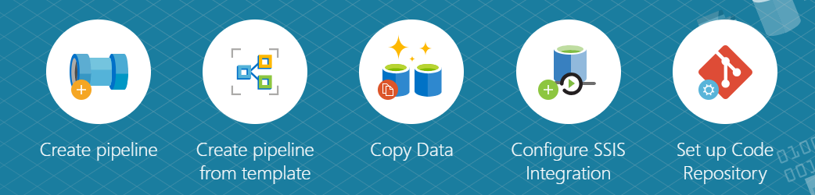

Hands-On Lab

Azure Data Factory

Mapping Data Flow

# Introduction

***Azure Data Factory*** (ADF) is a hybrid data integration service, designed to ease the construction of complex data movement pipelines. ***Mapping Data Flow***, a feature of ADF, is designed to enable graphical construction of data transformation pipelines, at scale, using the ***Azure Databricks*** Spark engine, without the need for any hand coding or Spark knowledge.

This hands-on lab will demonstrate the capabilities of ADF and Mapping Data Flow by using a sample template that introduces several Data Flow features. This lab will also implement a complex real-world data pipeline scenario that utilizes some of the template features.

# Prerequisites

Before starting this lab, you will need the following prerequisites:

1. An Azure Account that you have create rights in
   1. You will need to create your own resource group for this lab
2. An Azure Data Factory, created in the West US geographical region
   1. It is important that this is created in West US, otherwise the Mapping Data Flow feature will not be available
   2. Create in the resource group that you created above
   3. For the purposes of this lab, do not enable GIT integration
3. An Azure storage account, also in the West US geographical region
   1. Create in the resource group that you created above
   2. Create a BLOB container for the sample data. Make sure the container is named ***demo***
   3. Download all of the files located here: <https://github.com/kromerm/adfdataflowdocs/tree/master/sampledata>
   4. If you have git installed, you can simply clone the ***adfdataflowdocs*** repository to your local machine. If not, you can download a ZIP file containing all of the resources.
   5. Upload all sample files to the BLOB container that you created above
4. An Azure SQL Database
   1. Create a new database specifically for this lab
   2. Ensure that you know the SA password
   3. Ensure that you have SQL tools, such as Management Studio available

Once the prerequisites are created, you are ready to begin the lab.

# Exercise 1 – Deploying Data Flow Templates

In this exercise, you will deploy a new pipeline by using a template. The template will create example data flows that implement several data transformation capabilities that explain how Mapping Data Flow works to easily transform data.

1. In the Azure Portal, browse to the Data Factory that you created above and select the ***Author and Monitor*** link:

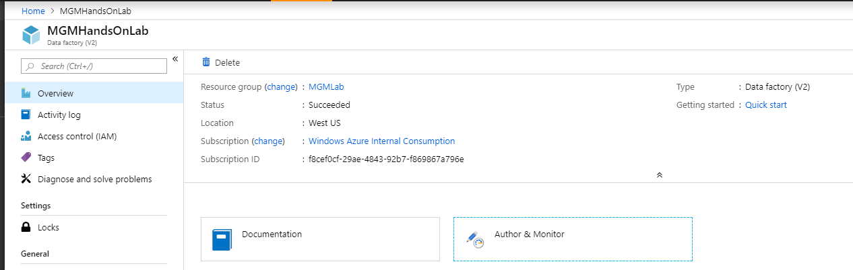

1. This will open the ADF Getting Started page:

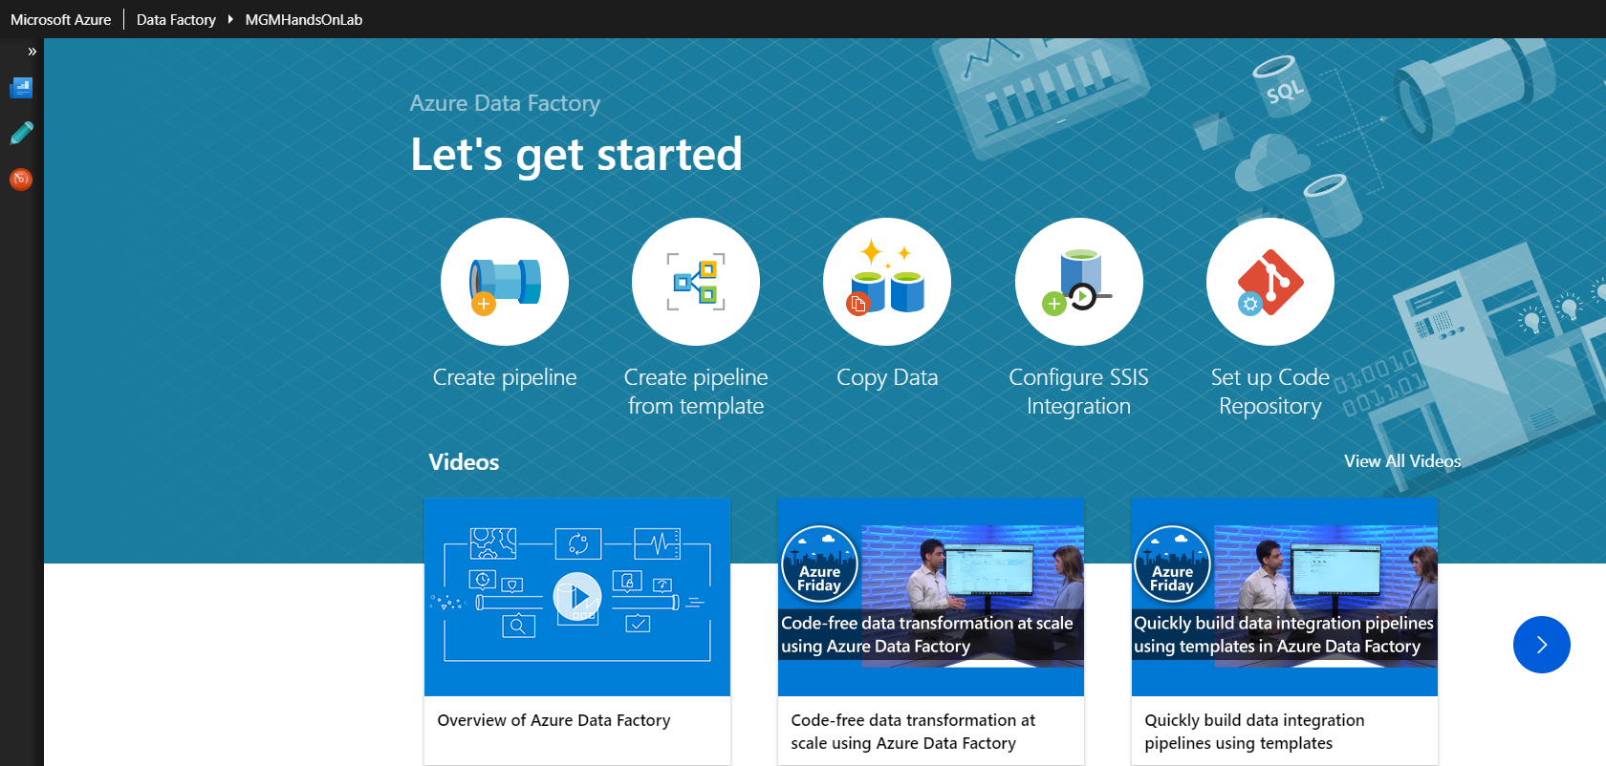

1. Click on ***Create pipeline from template***:

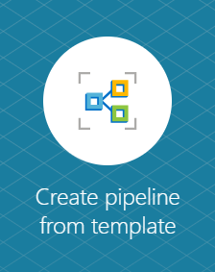

1. Choose the Data Flow tab

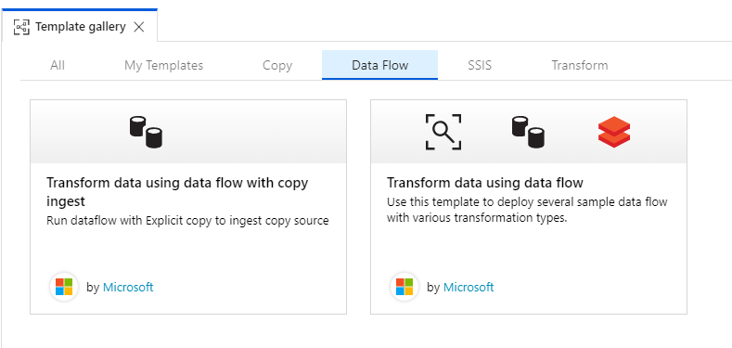

1. Choose Transform data using data flow
   1. This will deploy a new pipeline with several file attachments
   2. Select the ***CADOutput*** user input, then select the Source Blob Connection drop down, and select New. This will open the New Linked Service dialog

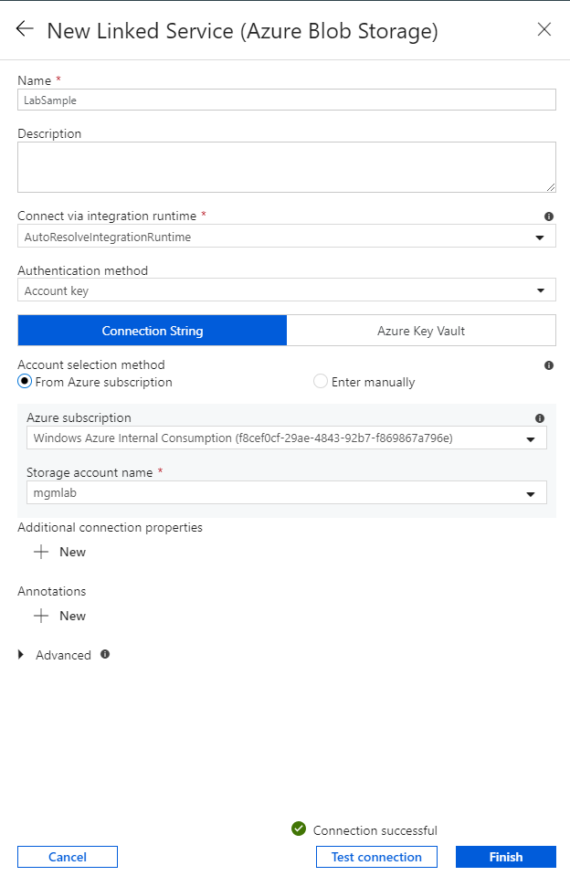

* 1. Fill out the form with the storage account information that you selected above and then select ***Test connection*** to verify. Once the verify is successful, select Finish to create the Linked Service. This will return you to the previous page with all Blob connections properly filled out.

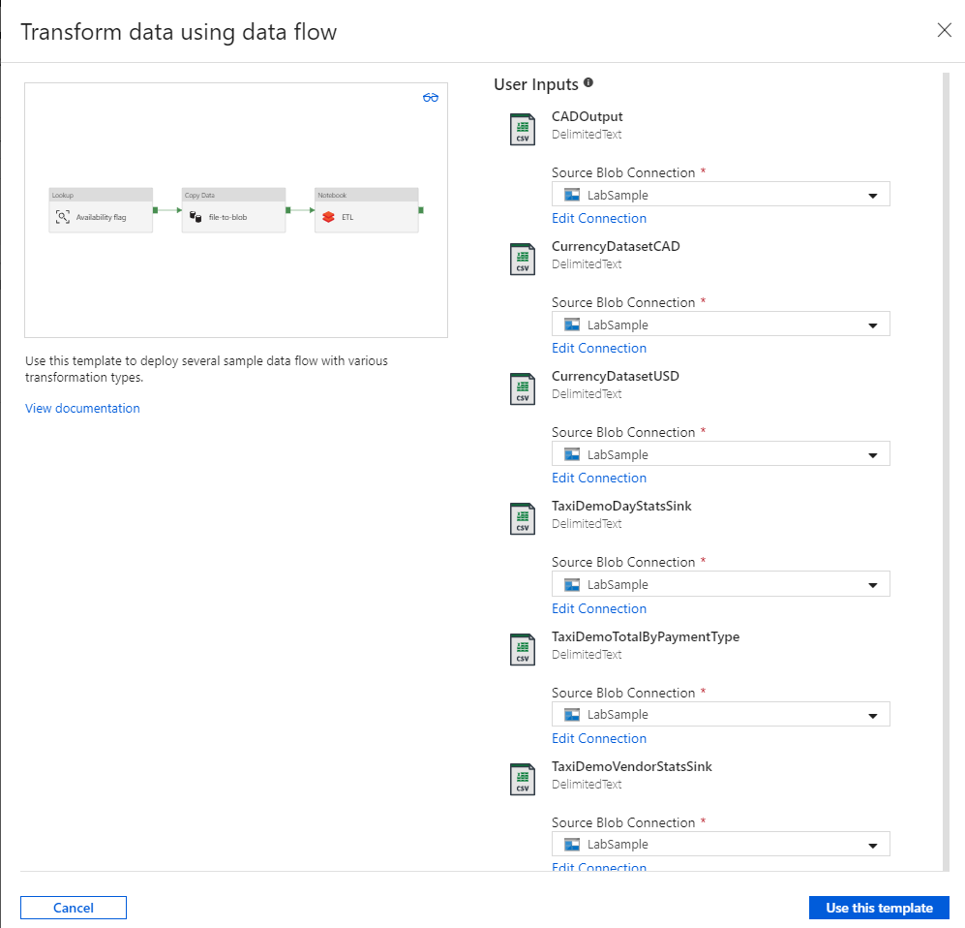

* 1. Click Use this template to deploy the template.

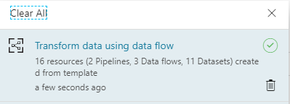

* 1. This will create 2 pipelines, 3 Data Flows, and 11 Datasets

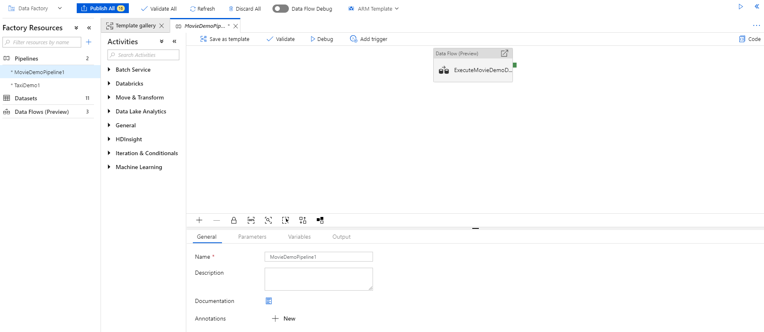

1. Select the Data Flows tab on the left side, and then select the MovieDemo1 Data Flow. This will open the Data Flow editor and display 3 components:

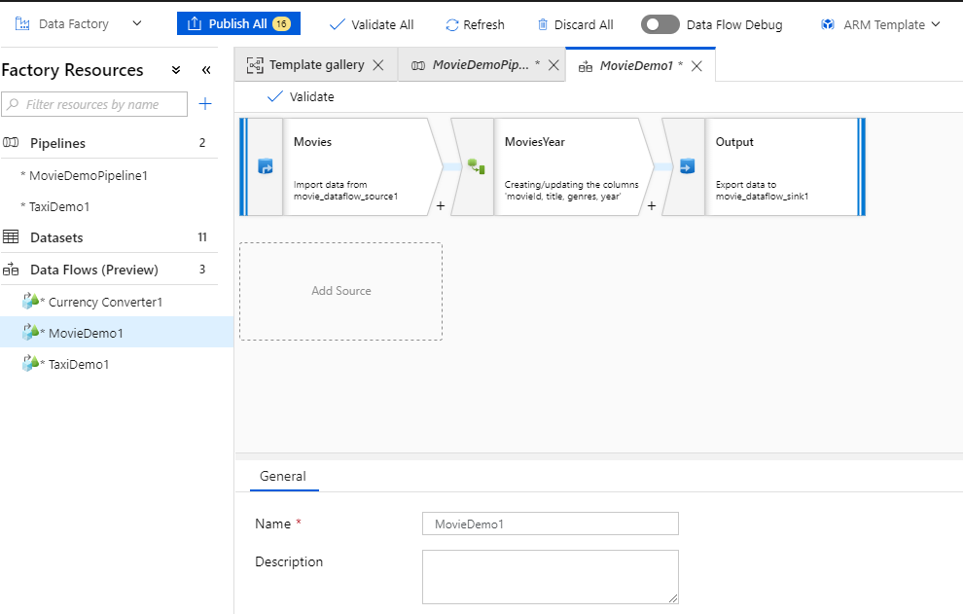

1. Select Movies, and explore the Source Settings:

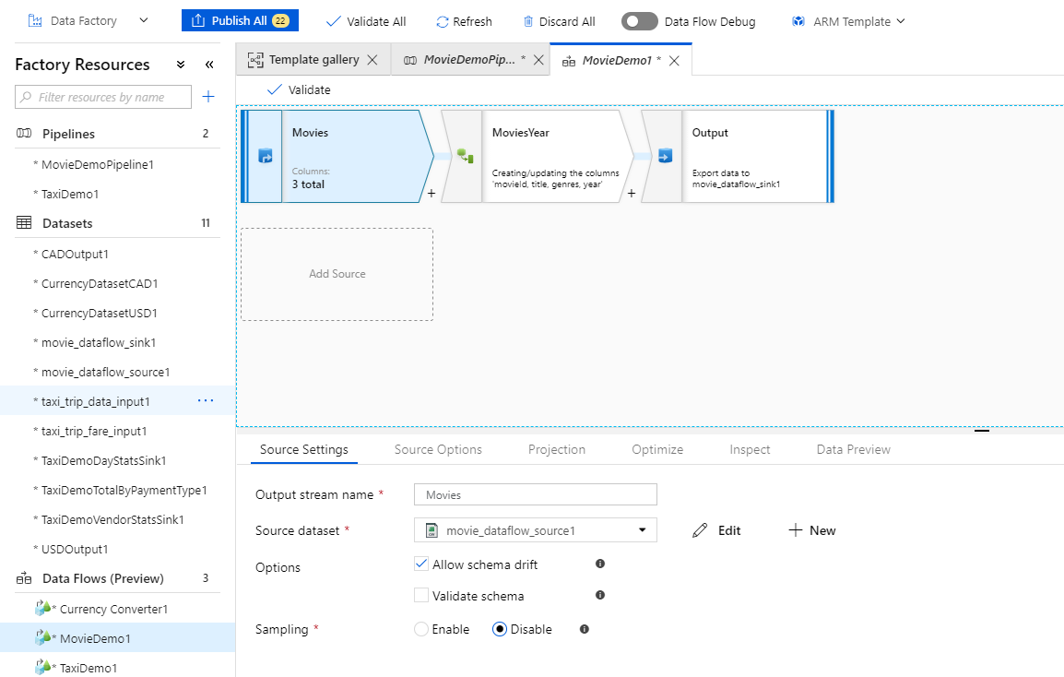

* 1. The Source dataset is ***movie_dataflow_source1***, which is a text file stored in the blob account that you created earlier. Click ***Edit*** and view the properties of the dataset

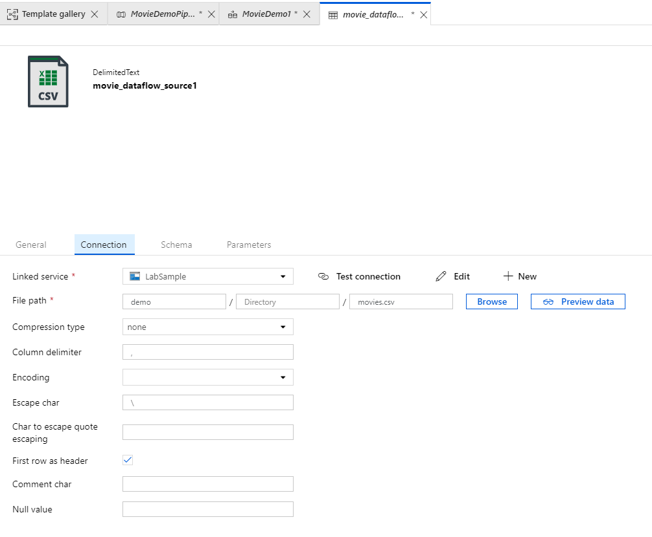

* 1. Click ***Preview data*** to view the first few rows of the dataset

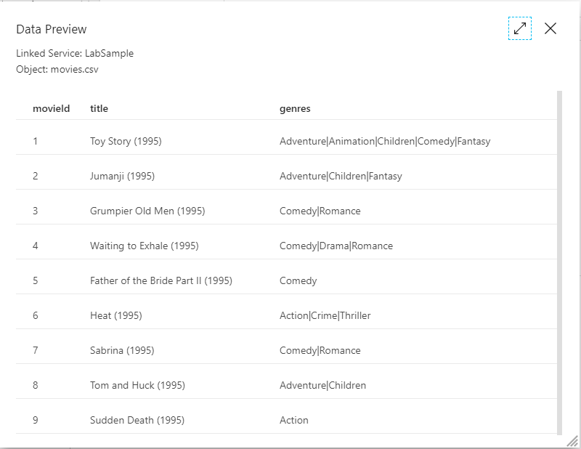

* 1. Click the ***Schema*** tab, and then select ***Import schema*** and select ***From connection/store***

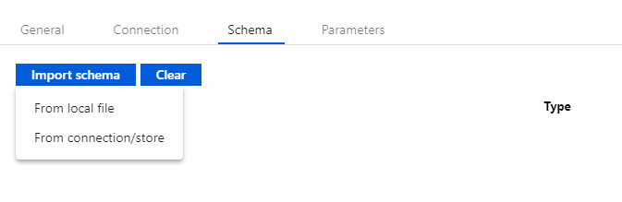

* 1. This will load the schema directly from the file

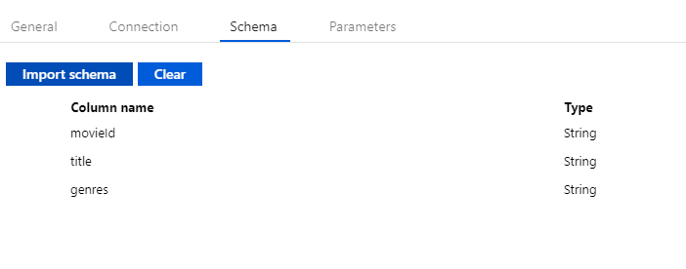

* 1. The schema matches the preview and displays 3 columns of Type String.

1. Click on the ***MovieDemo1*** tab, and then select ***Source Options***

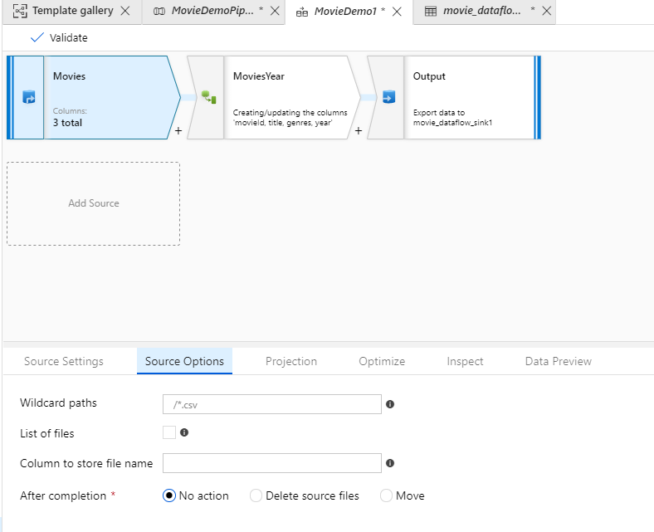

* 1. These options are very useful if you need to specify a list of specific files to process that aren’t easily addressed with a wildcard, or if you’d like to include lineage information in the data flow. The ***After completion*** radio button options allow you to easily delete or move source files once the process is complete.

1. Select the ***Projection*** tab

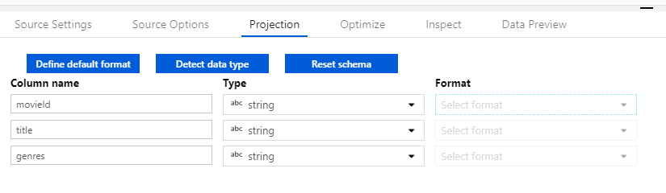

* 1. This is where you can perform simple data transformation or formatting (like date/time or currency)
  2. For this case, the Projection matches the schema of the source file

1. Select the ***Optimize*** tab

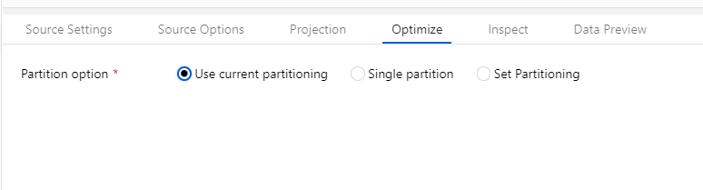

* 1. This is useful when you have large source files and need to partition accordingly
  2. In this case, the current partitioning is sufficient since the file is relatively small

1. Select the ***Inspect*** tab

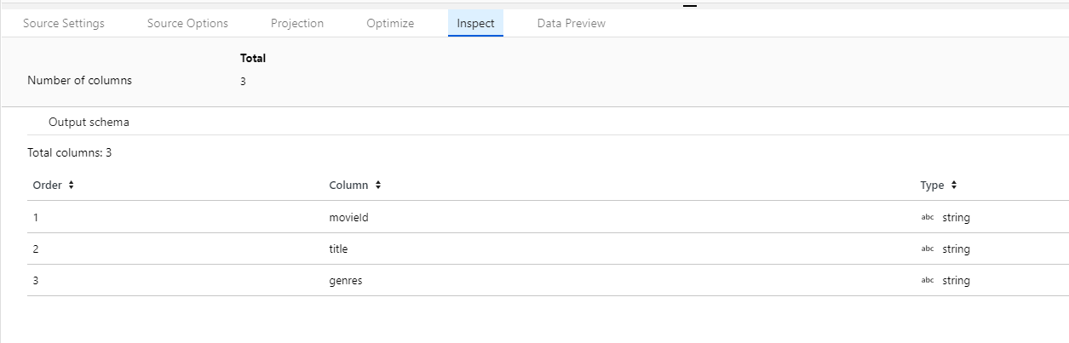

* 1. This shows the output schema with the column order, name, and datatype

1. Select the ***Data Preview*** tab

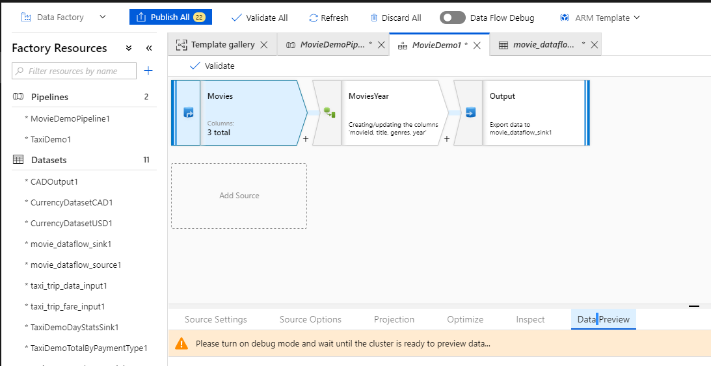

* 1. Enable Debug mode by sliding the Data Flow Debug button at the top of the screen to the right

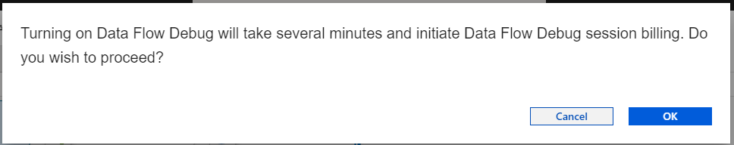

* 1. Click ***OK*** to provision the Databricks environment to execute the data flow. This will take several minutes to complete
  2. Once the cluster is ready (monitor the notifications icon in the upper right) click the ***Data Preview*** tab again, and then click ***Fetch Latest Preview***

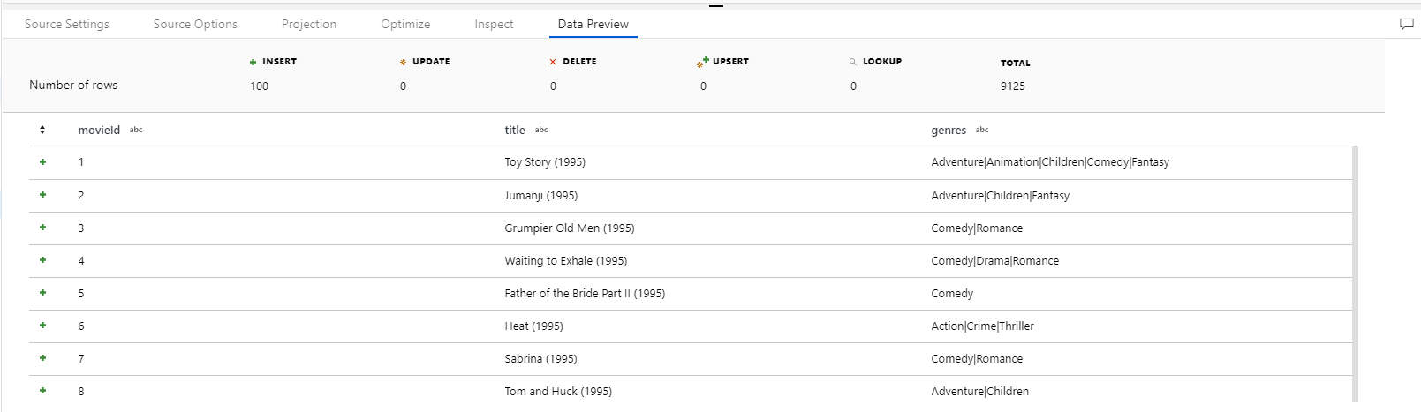

* 1. Note the format of the data in the title column. In the next section you will use a derived column object to extract the Year of the movie.

1. Select the ***MoviesYear*** object

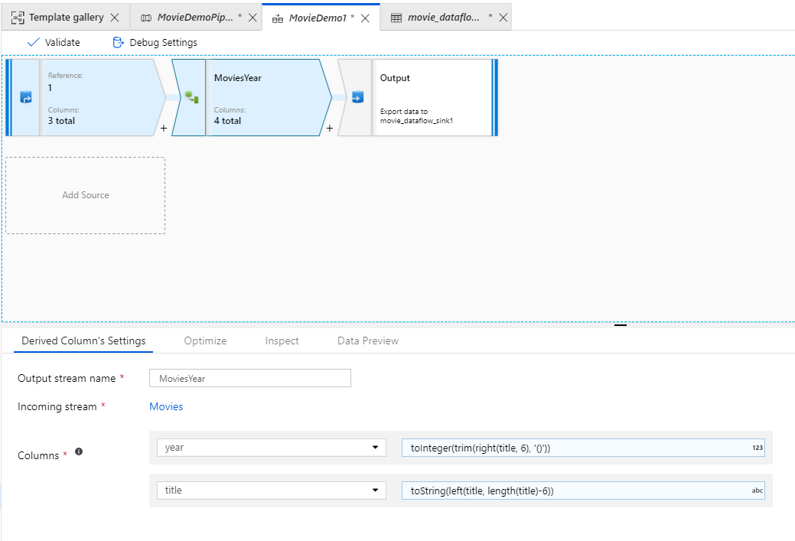

* 1. Examine the ***Derived Columns Settings***, and note the function being used to extract the year and the title. (In this example, year is an integer value that is extracted by trimming the parenthesis from the rightmost 6 characters, and the title is everything else)
  2. Click the ***Data Preview*** (and wait for the cluster to start again if it has stopped) and click Fetch Latest Preview

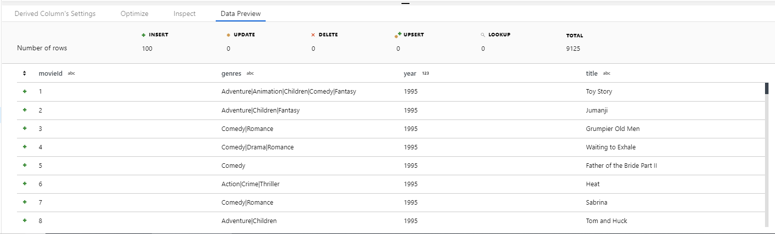

1. The dataset now contains the additional year and title columns
2. Click the Output object

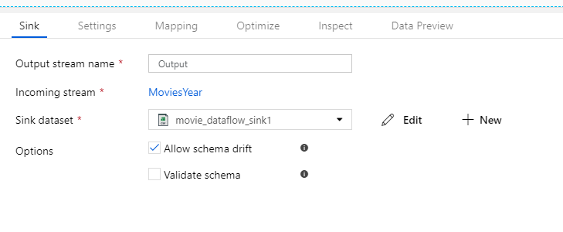

* 1. Note that the Sink dataset is ***movie_dataflow_sink1***. Click Edit and note the sink is a delimited text file

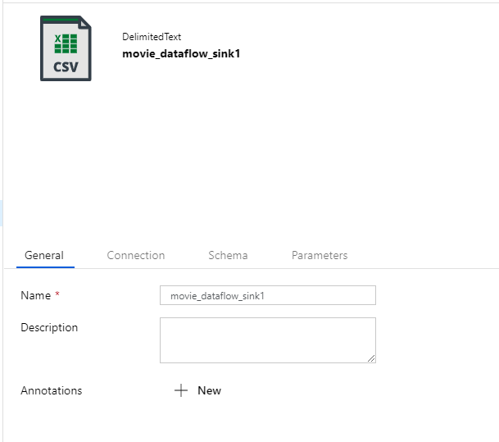

* 1. Click the ***Connection*** tab. Notice that there is no filename associated with the sink. This will be generated at runtime.

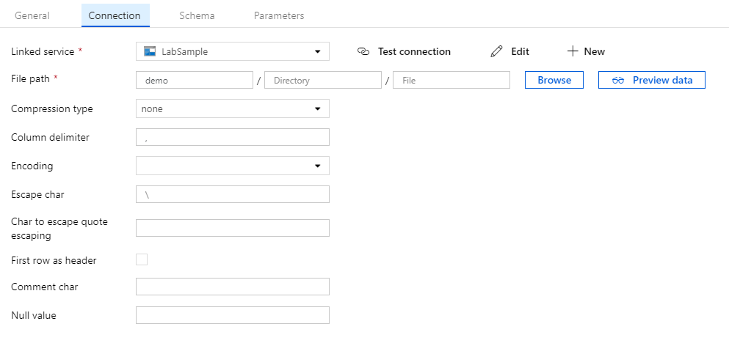

* 1. Note that the output file will be a text file with comma delimiters and a backslash for the escape character

1. Click on the ***MovieDemo1*** tab to return to the Output object, and then click the ***Mapping*** tab to verify that the data mappings are correct

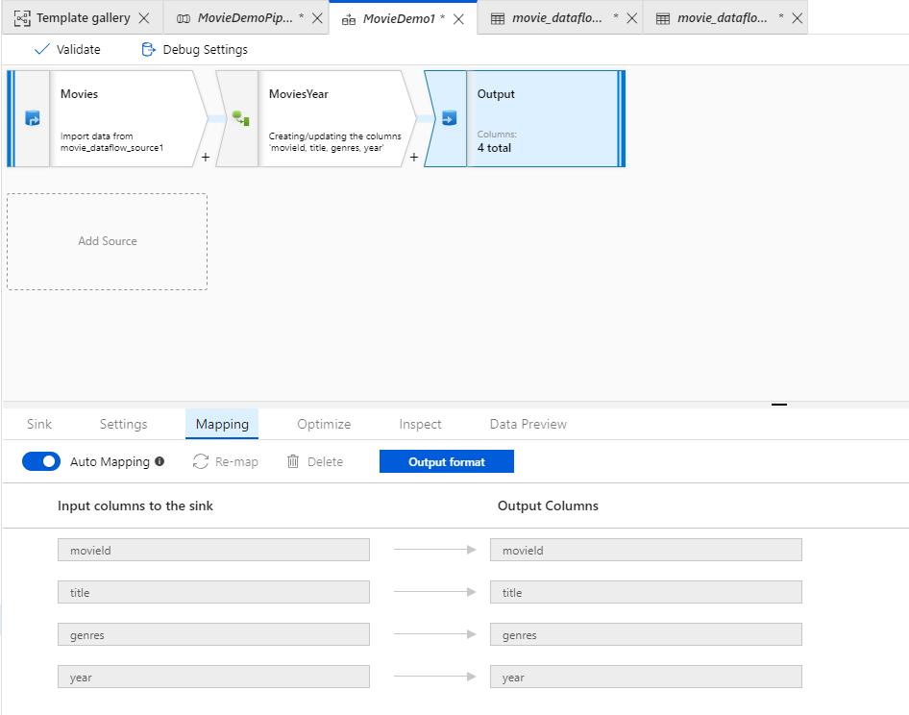

1. Click on the ***Data*** ***Preview*** tab, and then click ***Fetch latest preview data*** to view the data

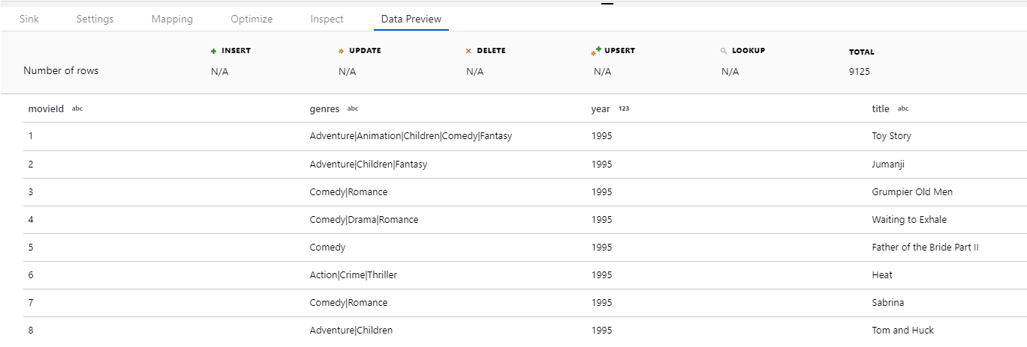

1. The Data Flow is now ready to execute. Select ***Publish*** ***All*** in the upper-left of the window, and wait for the publish process to complete (monitor the alerts dialog in the upper right to verify completion)

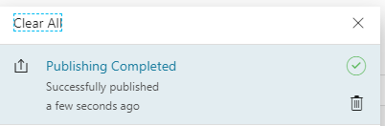

1. Click on the ***MovieDemoPipeline*** tab to return to the pipeline. Notice that there is only one object, which is the Data Flow Execution object. This simply is an orchestration container to execute the Data Flow that we just examined

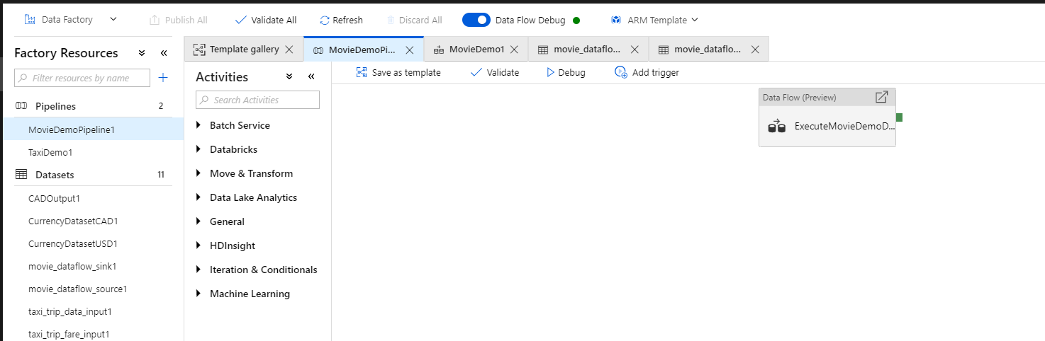

1. Select ***Debug*** to execute the pipeline. This will open the execution monitor in debug mode

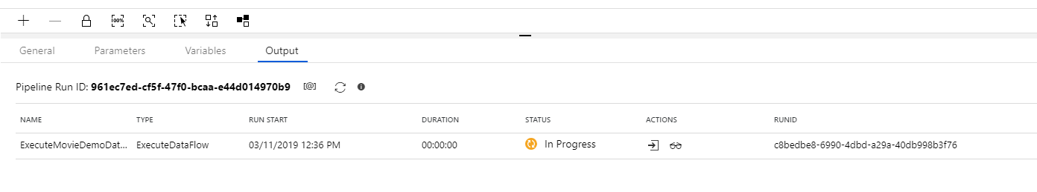

* 1. Click the eyeglass icon in the ***Actions*** column to view detail of the execution (You may have to refresh the pipeline run to see results)

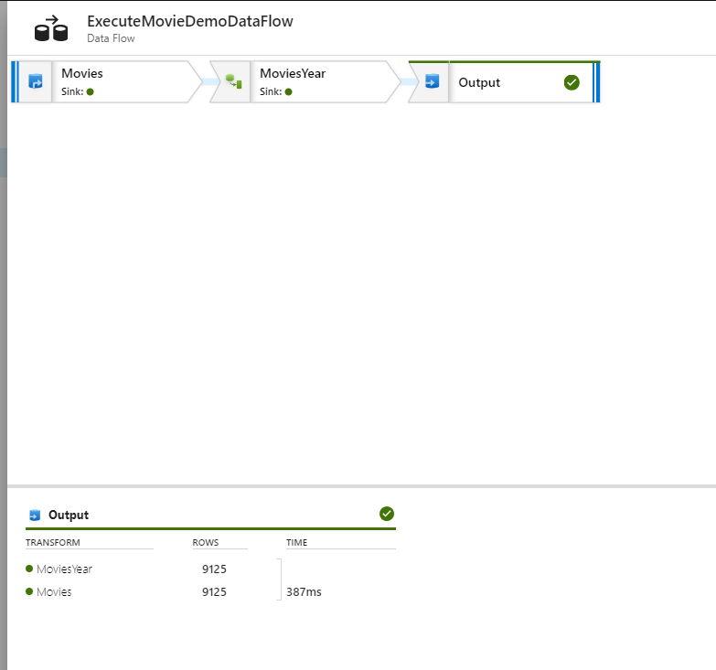

* 1. Once the execution completes, you will see results such as the above

1. To view the contents of the output file, use either Azure Storage Explorer, or the Azure Portal to view the contents of the storage container that you created earlier. You will note that there are new files in the container. Select the file that begins with part-00000 and select View/Edit Blob from the context menu. This will open the editor and display the contents of the file.

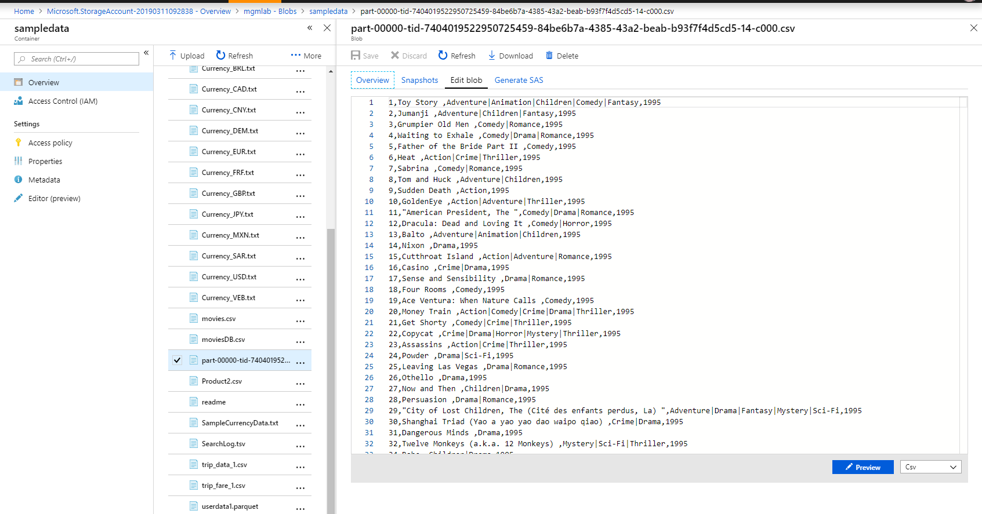

In this exercise, you deployed a new Azure Data Factory Mapping Data Flow by using a template. You then walked through a simple Data Flow that read data from a text file, transformed the data by splitting a column into multiple columns, and then output the data to a new text file.

Clean up the environment by closing all of the tabs in the Data Factory Window

# Exercise 2 – Examining a Complex Data Flow

In this exercise, you will examine a complex data flow that uses joins and aggregations to transform data. The dataset used in this example is from the New York City Taxi and Limousine Commission, and provides data related to trips and charges. A full description of the dataset can be found here: <https://www1.nyc.gov/site/tlc/about/tlc-trip-record-data.page>

1. In the Azure Data Factory UI, select the ***TaxiDemo1*** Data Flow (you may have to resize the bottom portion of the screen to view the entire Data Flow)

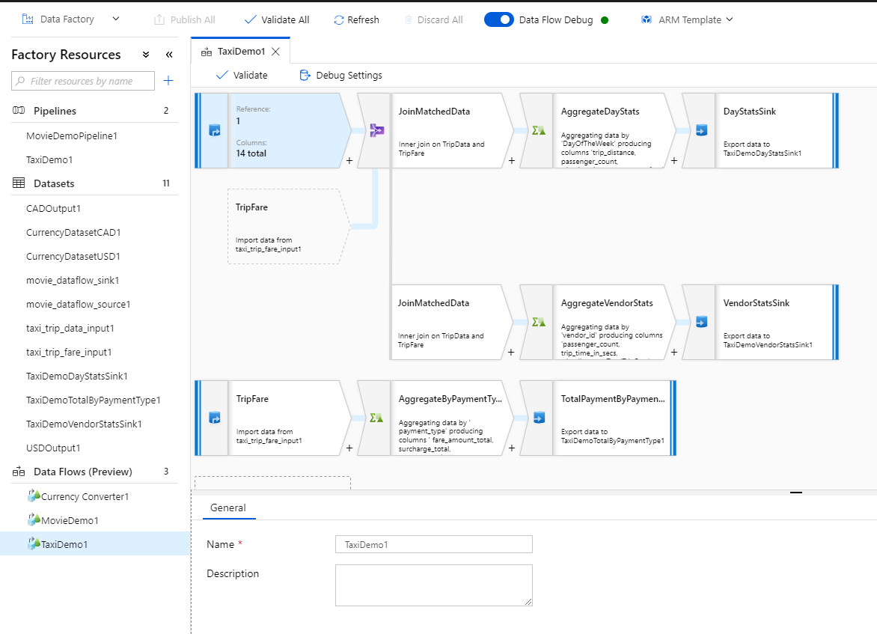

1. Select the ***TripData*** object and view the ***Source Settings.*** Examine each of the tabs, including the ***Data Preview***, by using the same technique you used in the previous exercise (do NOT import the schema however as this will break downstream objects at this point)

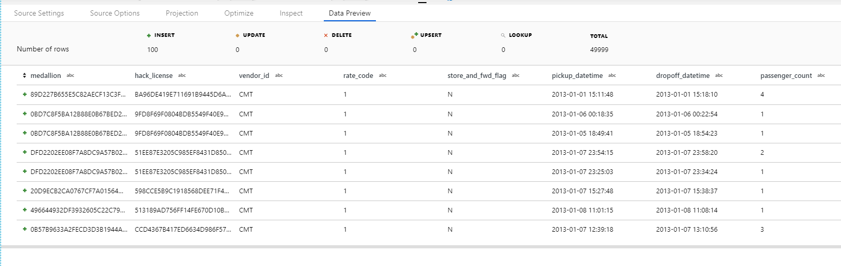

1. Select the ***TripFare*** object that is connected to the ***JoinMatchedData*** object and view the ***Source*** ***Settings***. Examine each of the tabs including the ***Data Preview***

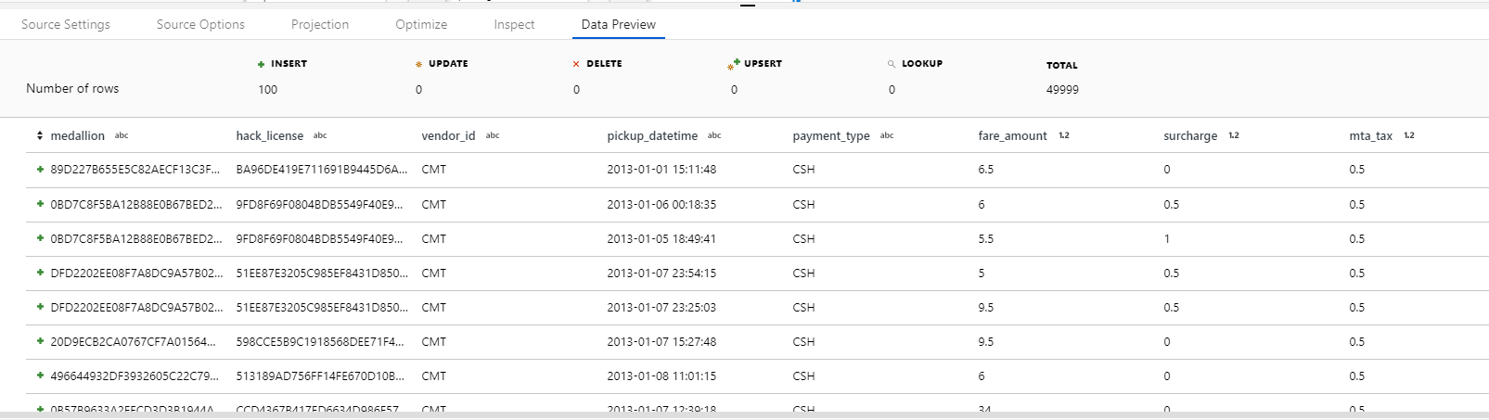

1. Select the JoinMatchedData object. Note how the two datasets are joined.

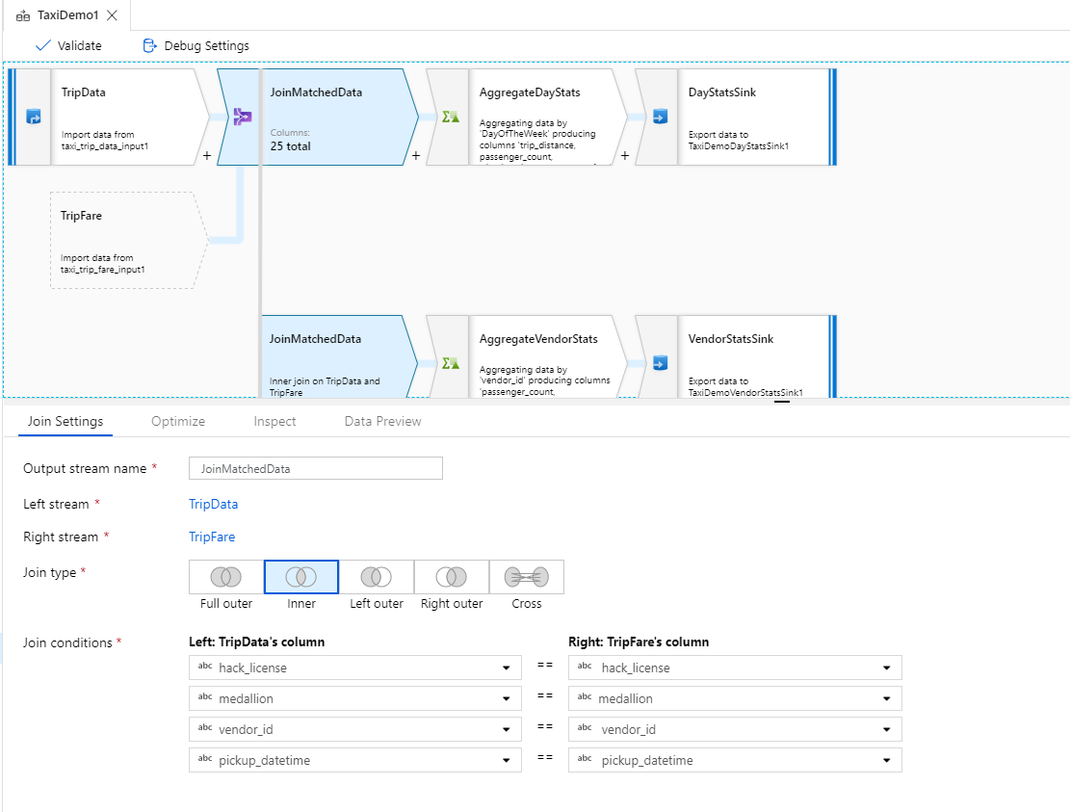

* 1. This will join the data where each of the above columns match.

1. Click the ***Data Preview*** tab and ***Fetch latest preview data*** to view the results of the join

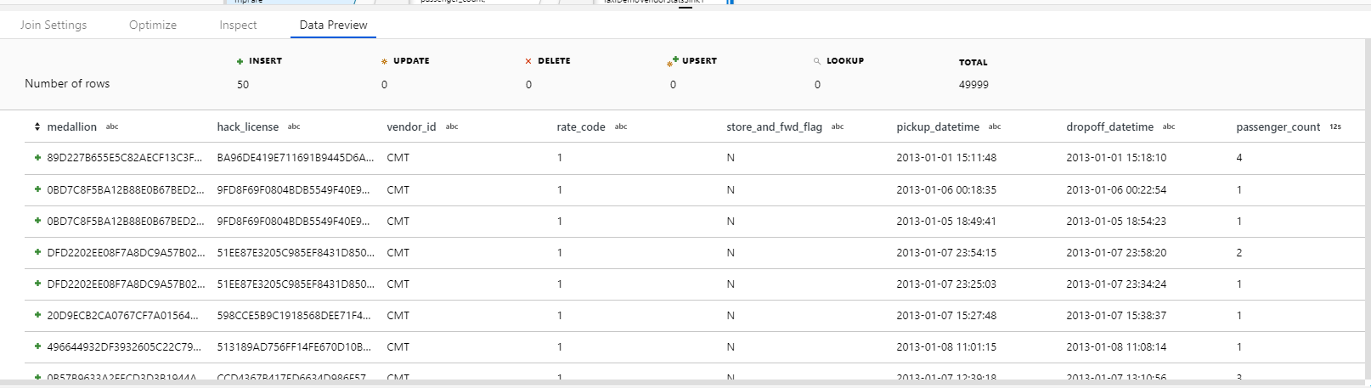

1. Click the ***AggregateDayStats*** object and note the group by formula

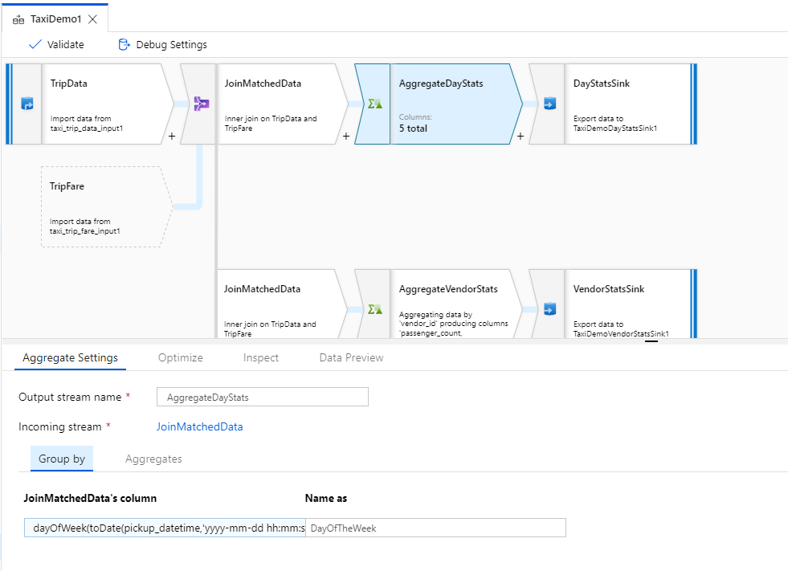

* 1. This will group the output by the calculated day of the week, derived from the ***pickup_datetime*** column.

1. Click the ***Aggregates*** tab and note the calculations that will be performed on the data

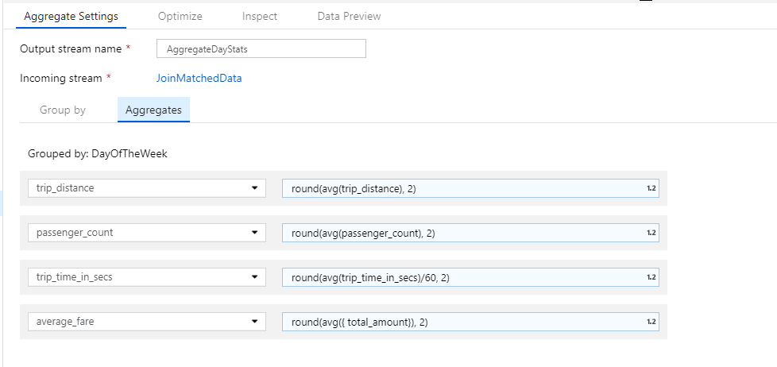

* 1. This will create average values for each of the columns specified, grouped by the calculated day of the week

1. Click the ***Data Preview*** tab and ***Fetch latest preview data*** to view the results

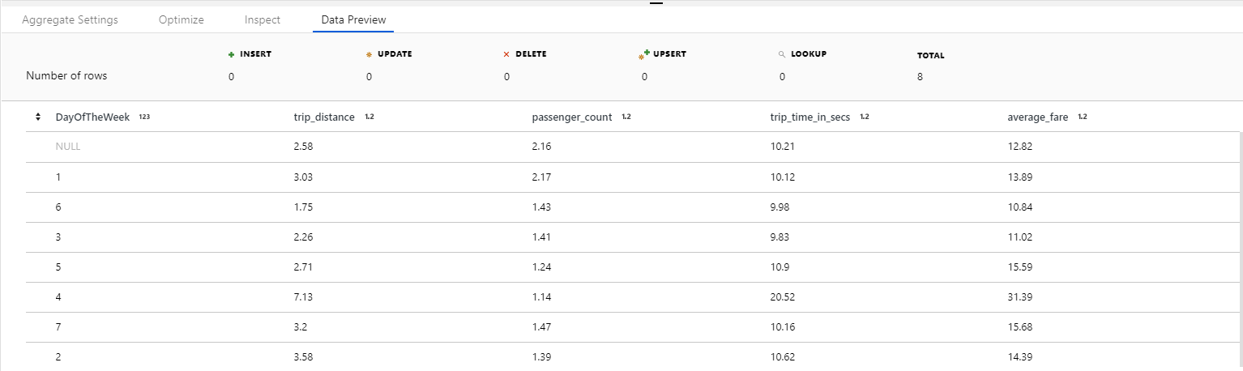

1. Click the ***AggregateVendorStats*** object, note that the grouping will be by ***vendor_id***

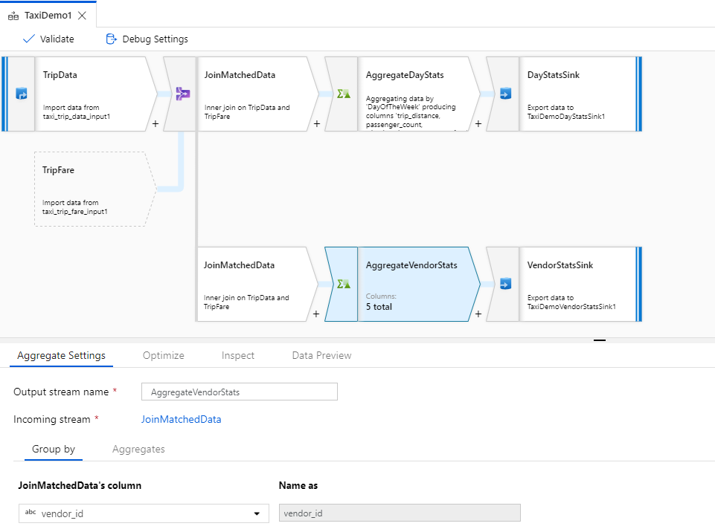

1. Click the ***Aggregates*** tab and note the calculated values

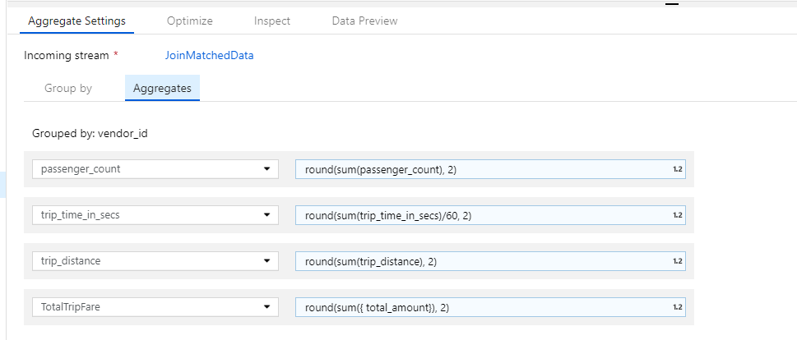

* 1. This will create average values based on the columns shown, grouped by ***vendor_id***

1. Click the ***Data Preview*** tab and ***Fetch latest preview data***

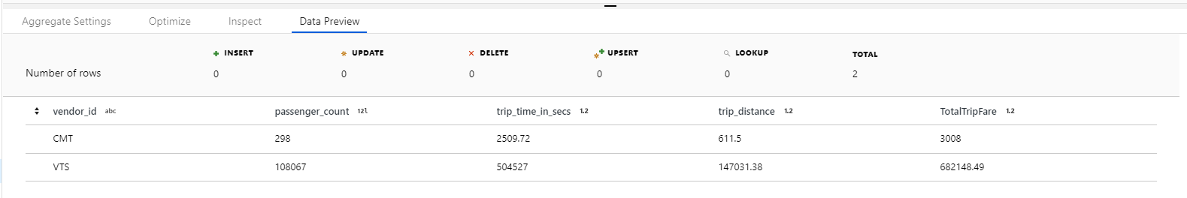

1. Click the lower ***TripFare*** object and note the various configuration options. Preview the data to view the dataset

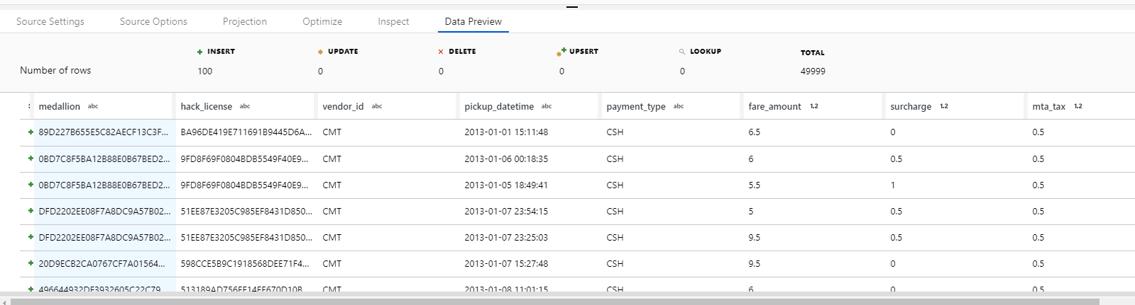

1. Click the ***AggregateByPaymentType*** object and note that the data is grouped by the payment_type column

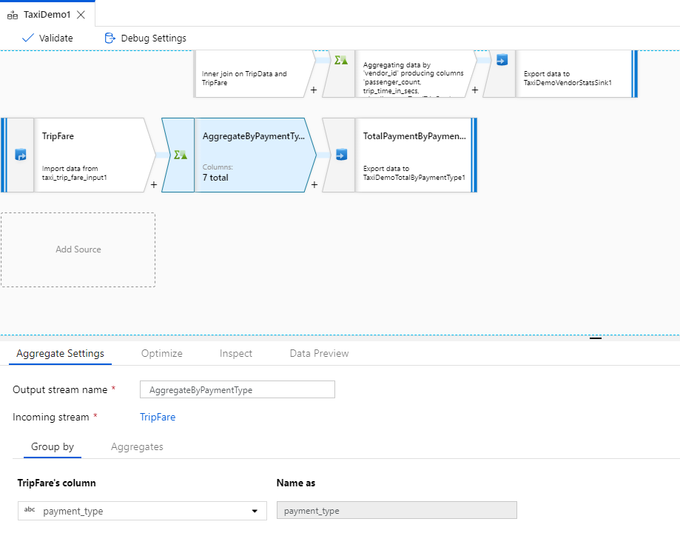

* 1. Click the ***Aggregates*** tab and note the formula used for the calculations

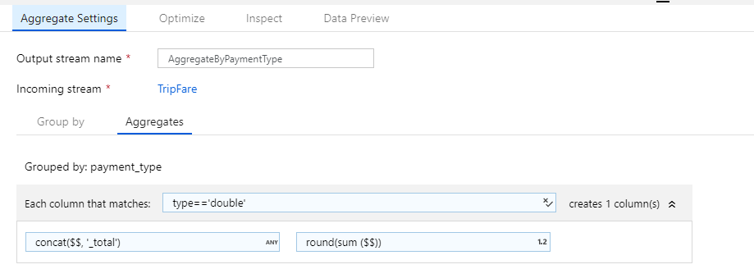

* 1. This formula calculates the SUM of each column in the source data that is of double datatype and then names the column the original name plus _total
  2. Click the ***Data Preview*** tab to view the results of the aggregation

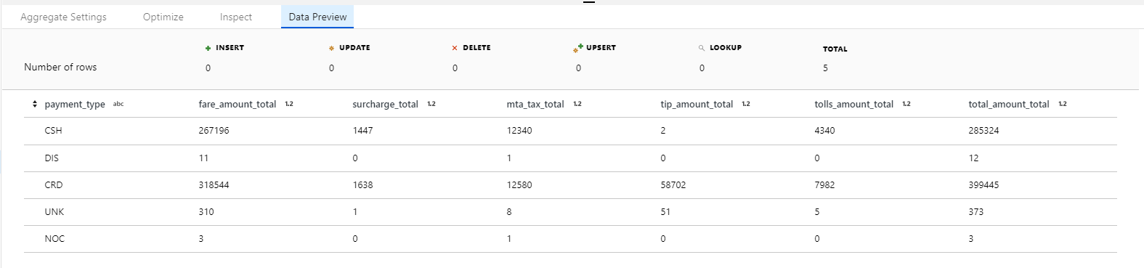

1. When the Data Flow is executed, the output will be 3 files containing statistics by day of week and by vendor, as well as total payments by type
2. Click on the ***TaxiDemo1*** pipeline and click Debug to execute the pipeline. Use the details (the eyeglasses) icon to view the transformation details.

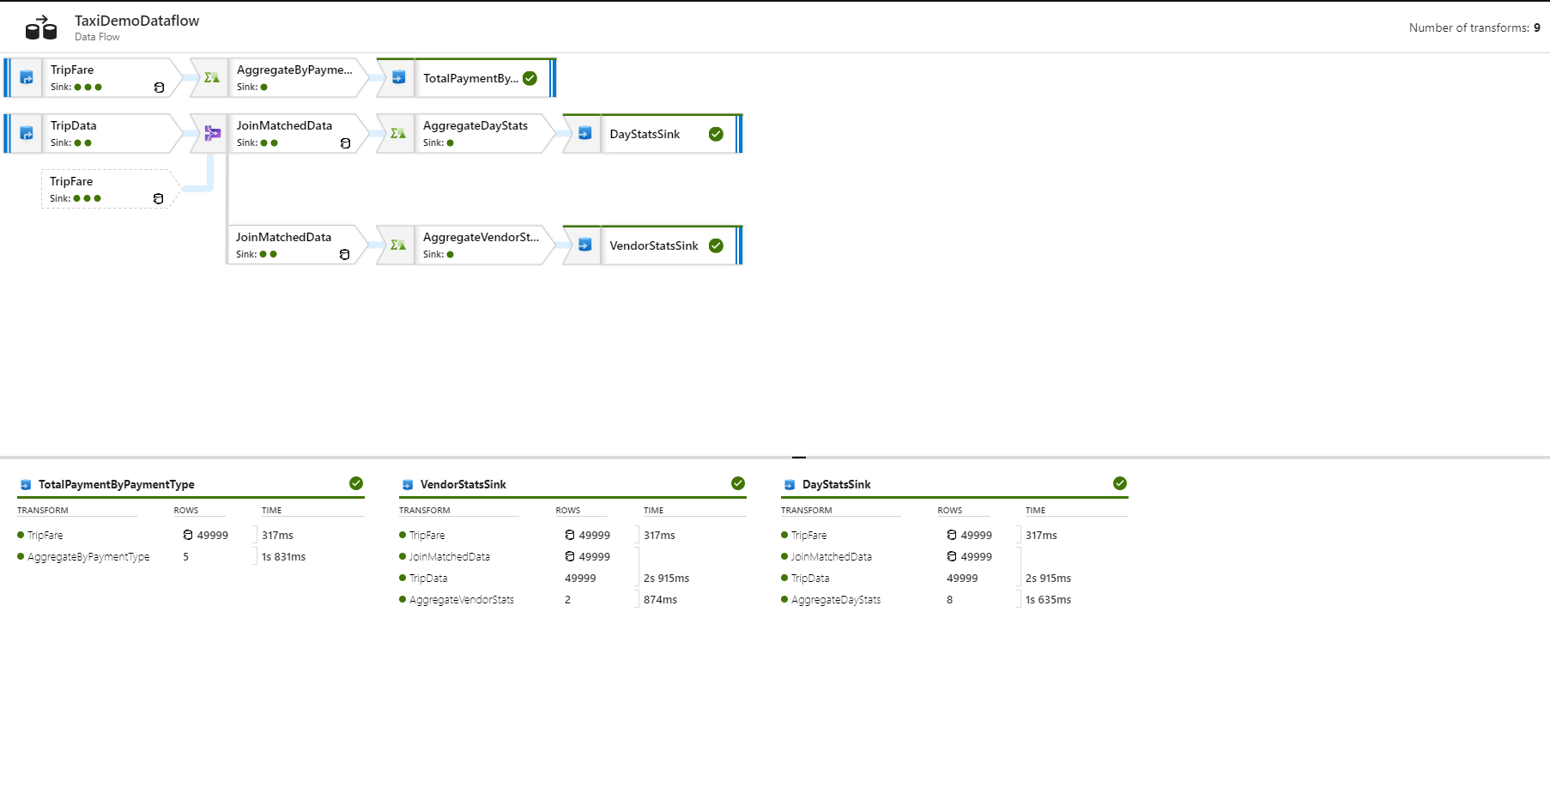

In this exercise you examined a complex data flow that used joins and aggregations to create output files. You then executed the data pipeline in debug mode to view the results.

Before moving to the next exercise, clean up the Data Factory UI by closing all tabs and returning to the blank canvas.

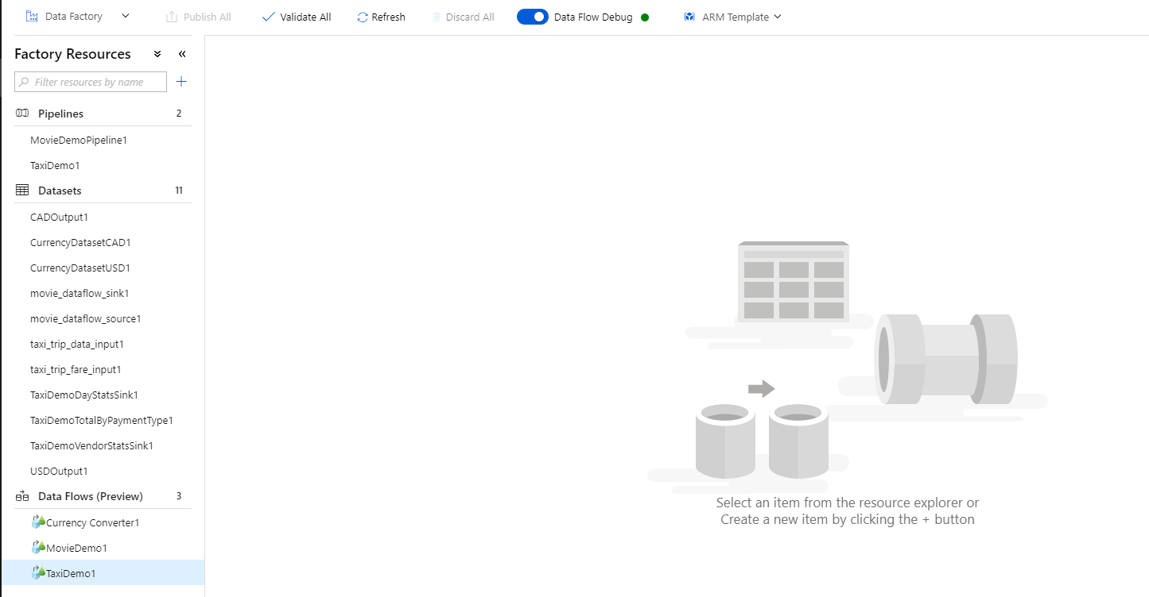

# Exercise 3

In previous exercises you used a pre-constructed Pipeline and Data Flow in order to view concepts that are used to construct Data Flows. These Data Flows were examples that simply read from a file and output to a file. In this exercise, you will create a Pipeline and Data Flow from “scratch” that is designed to implement a specific business scenario that will read data from a web service (using the SODA protocol, which is a generic http web service), transform the data, and output to an Azure SQL Database instance.

## The Scenario

The City of Chicago publishes data for each police report that is filed within the city. This data is made available via a web service connection.

In this exercise you will construct a new data flow that extracts the information from the web service, enhances it with additional data, create aggregations, and sink the data to an SQL Database. You will also monitor and debug the pipeline and learn how portions of a pipeline can be re-executed in the event of failure.

1. In the ***Data Factory UI***, click the ellipse (…) to the right of Pipelines and select ***Add Pipeline***. Name the new pipeline ***CrimeDataPipe***

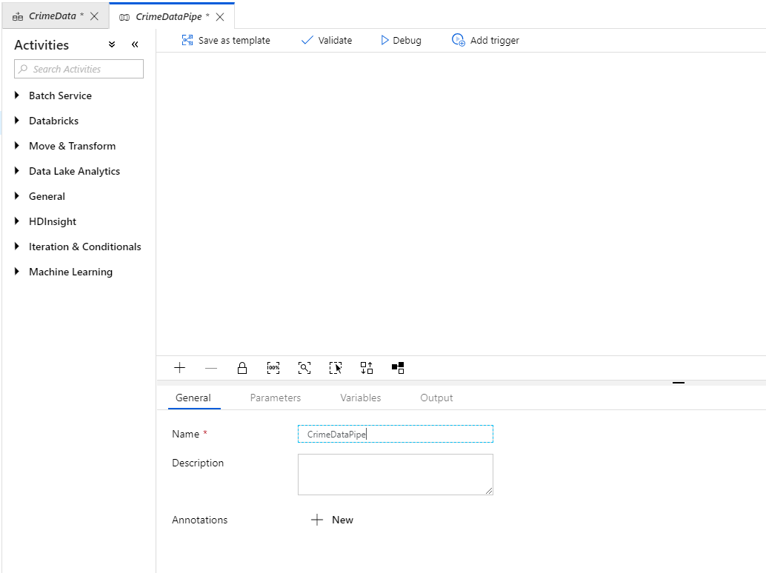

1. From the ***Move & Transform*** section on the left, drag a ***Copy Data*** object onto the canvas and name it ***CopyCrimeData***

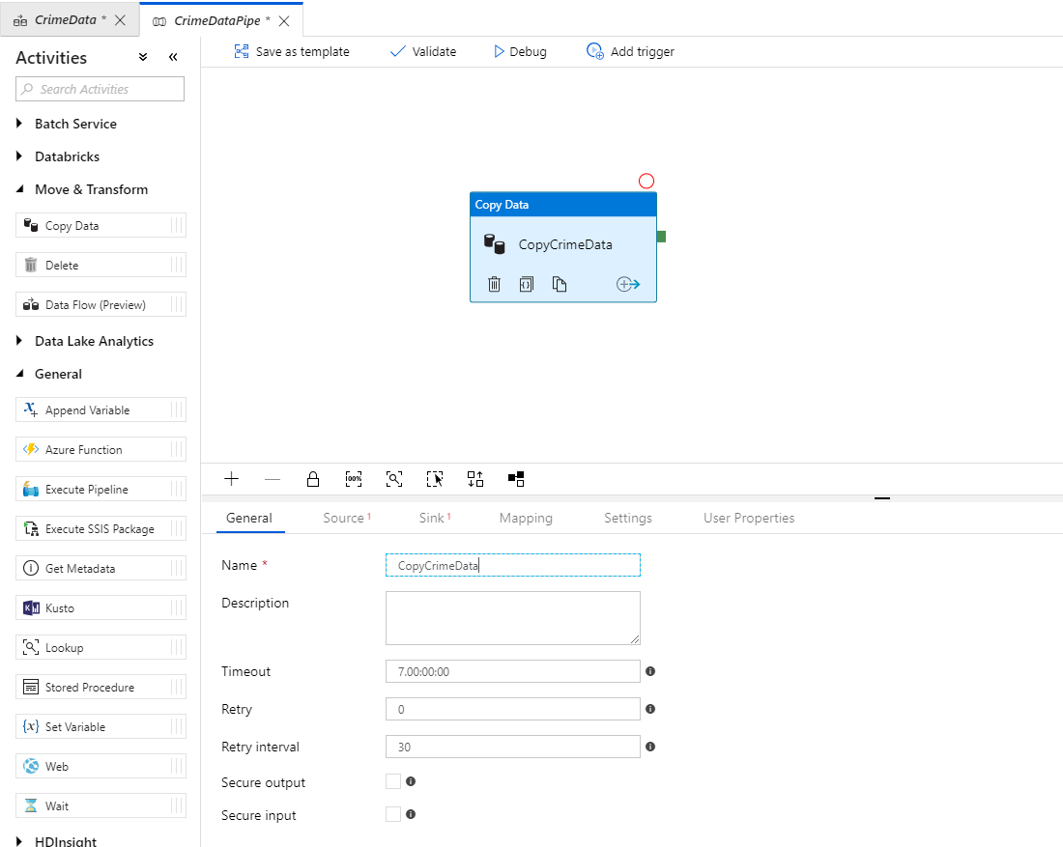

1. Select the ***Source*** tab, then click ***New*** to create a new source. Search for ***http*** in the list and click ***Finish***

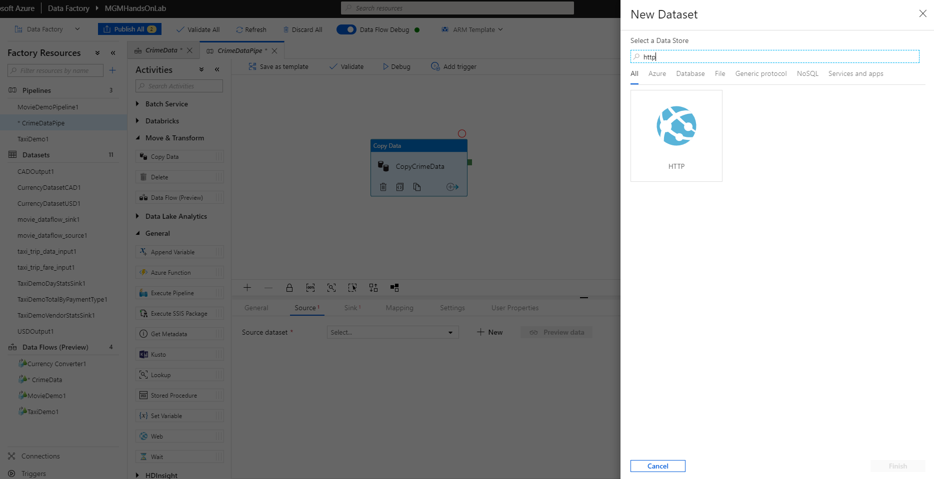

1. Name the source ***SODACrimeAPI*** (You will be connecting to an API using the SODA protocol)

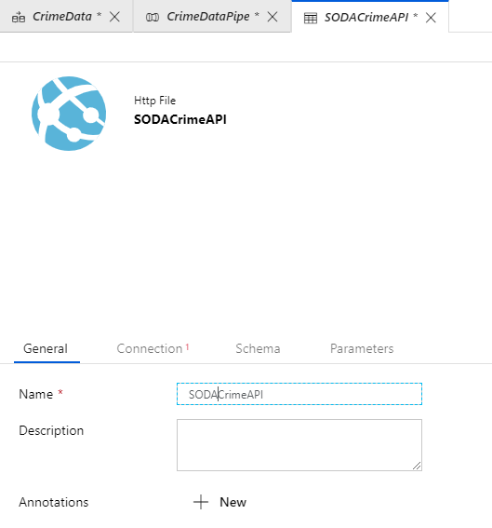

1. Click the ***Connection*** tab and create a new Linked Service. Name the Linked Service ***ChicagoCrime***. Use <https://data.cityofchicago.org/resource/crimes.json?$limit=50000> as the ***Base URL*** and select ***Anonymous*** for the ***Authentication type***

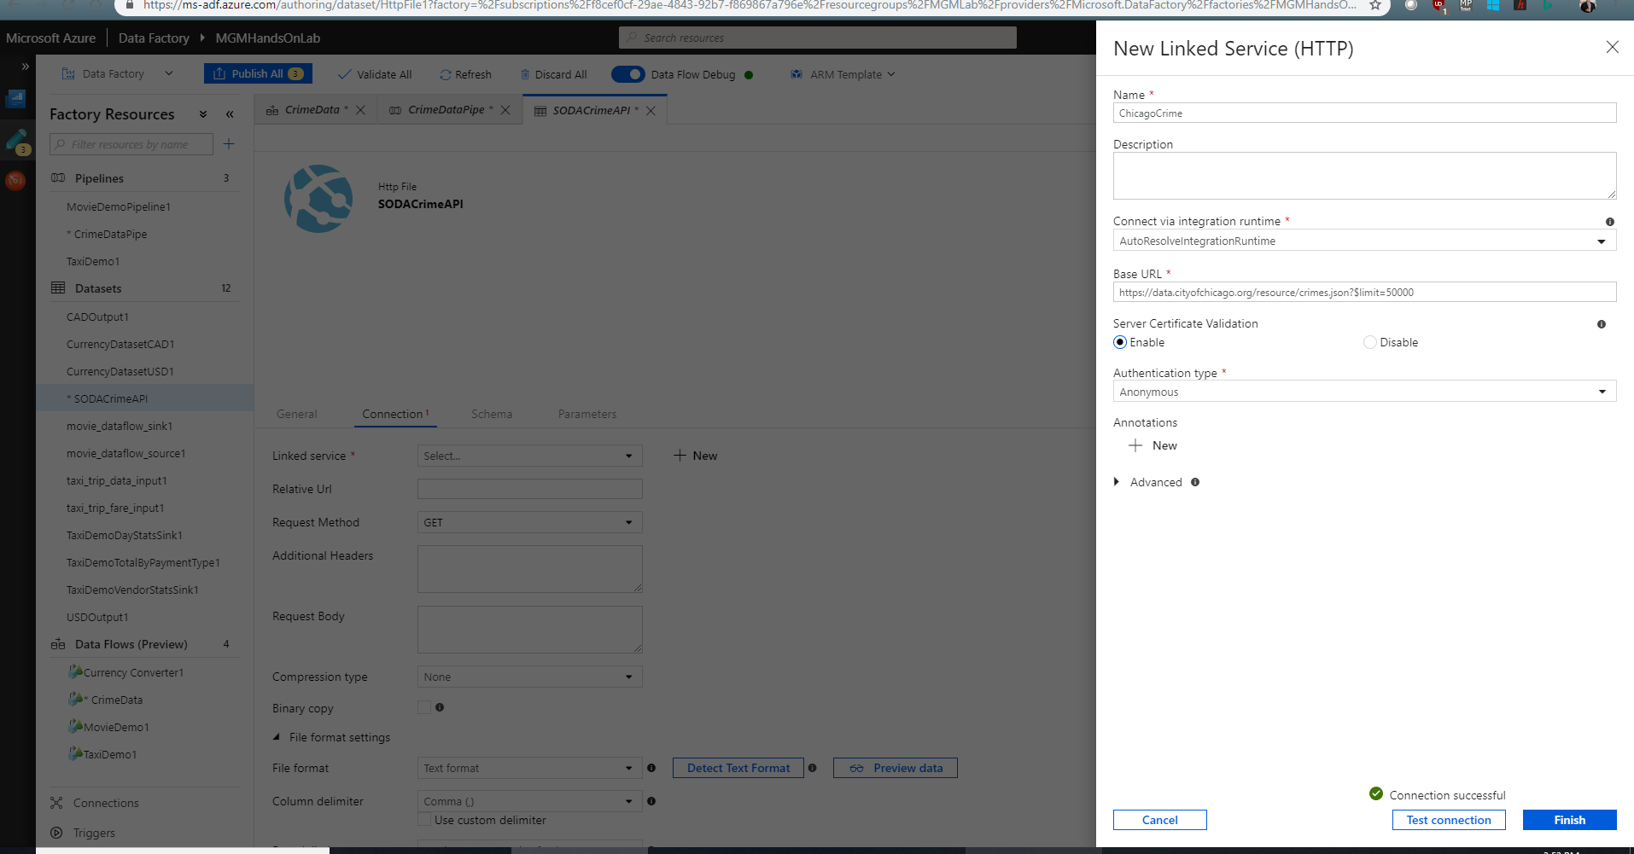

1. Click ***Test connection*** to verify that you have the correct URL, and then click ***Finish*** to create the new Linked service.
2. Select ***JSON format*** for the File format, and ***Array of objects*** for the file pattern

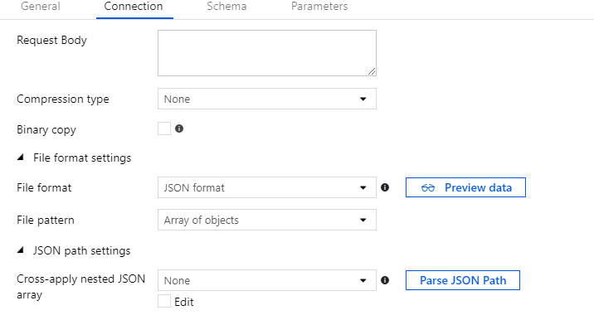

1. Click ***Preview data*** to view a preview of the data

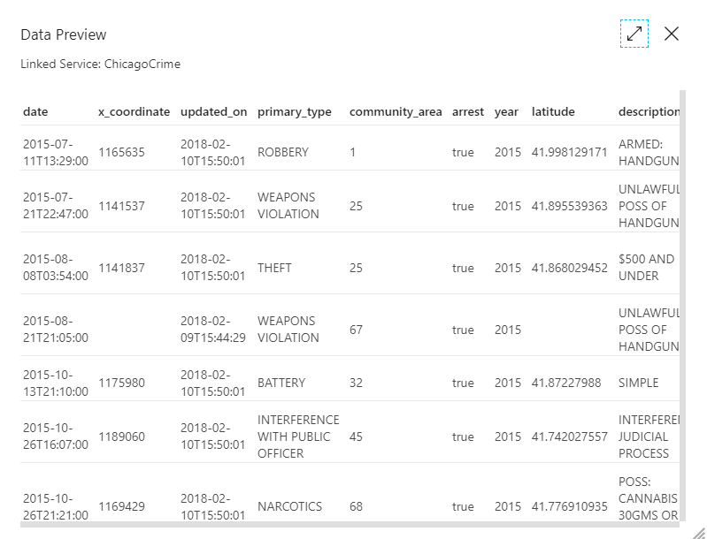

1. Click the ***Schema*** tab and then click ***Import schema***

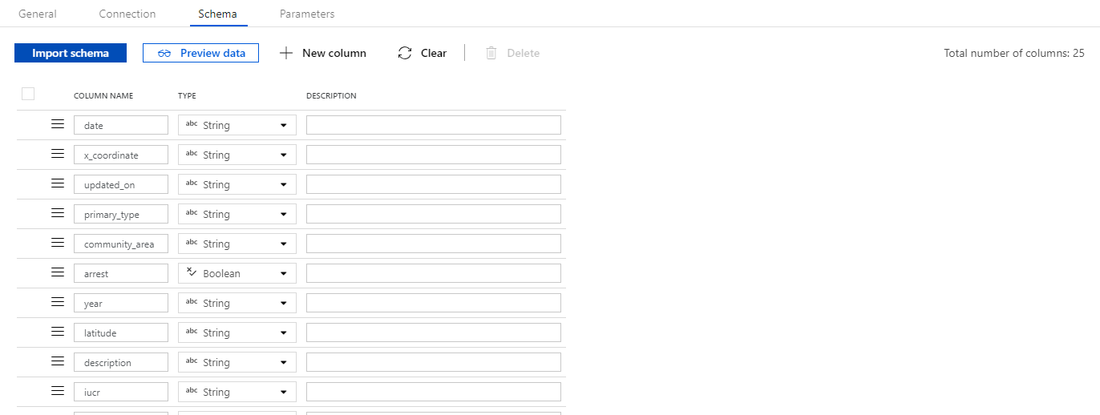

1. Select the ***CrimeDataPipe*** tab, select the **Sink** tab, then select **New Dataset**. Click on ***Azure Blob Storage***, and click ***Finish***

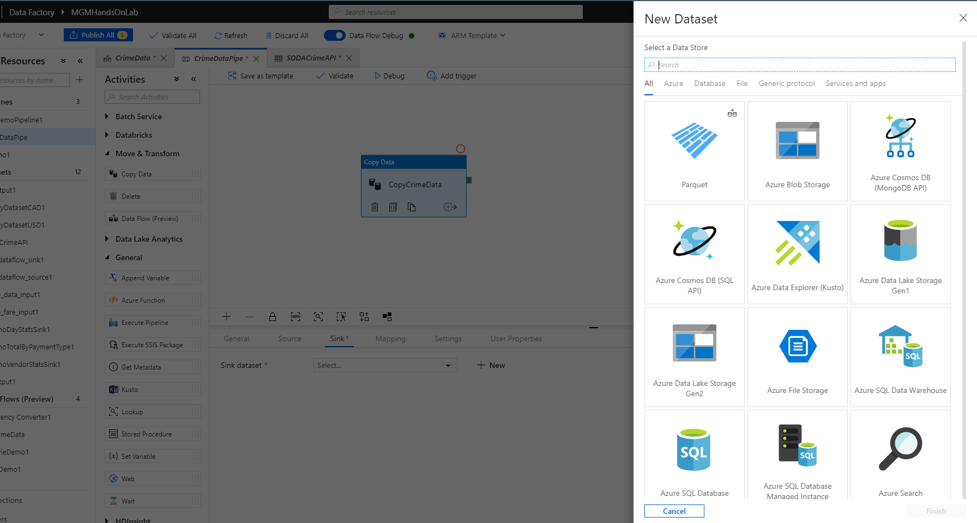

1. This will open a new ***Blob Storage*** connection tab. Name the connection ***ChicagoCrimesFile***

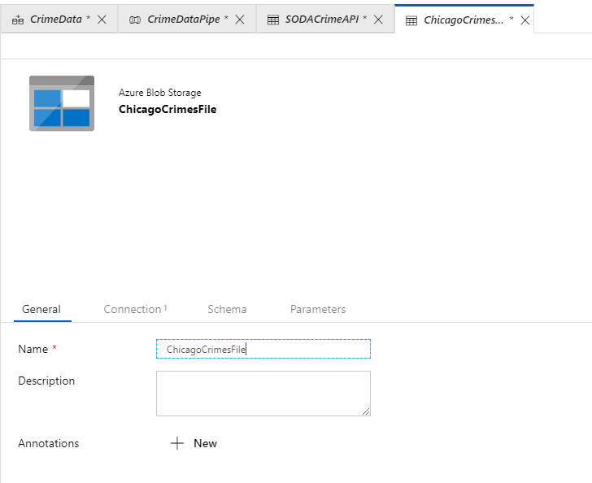

1. Click the ***Connection*** tab and select ***LabSample*** in the ***Linked Service*** drop down. Click the ***Browse*** button and select the ***outputs*** folder that you created as part of the prerequisites. Enter ***ChicagoCrimes.csv*** as the filename

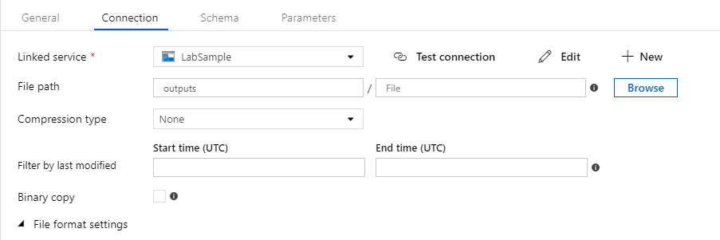

1. Select Text format, check Column names in the first row, and type a double quote (“) in the Quote character under Advanced settings

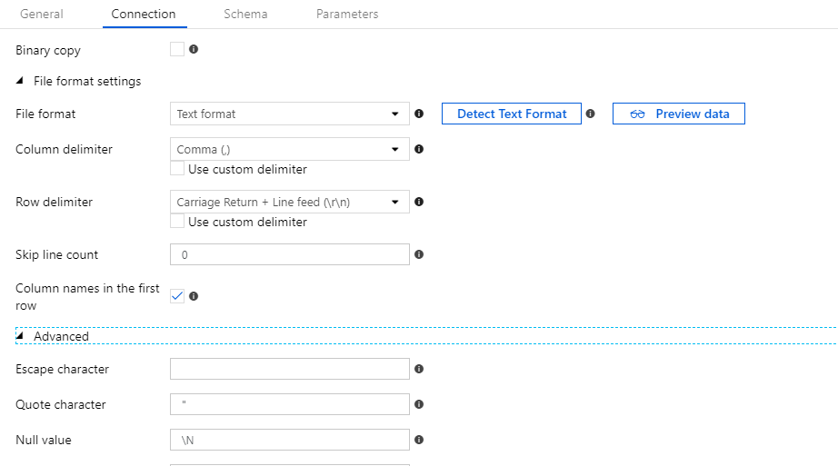

1. Click ***Publish All*** to publish all changes, and then close all tabs except the ***CrimeDataPipe*** tab
2. In the CrimeDataPipe tab, click Debug to begin execution of the Pipeline and create the output file

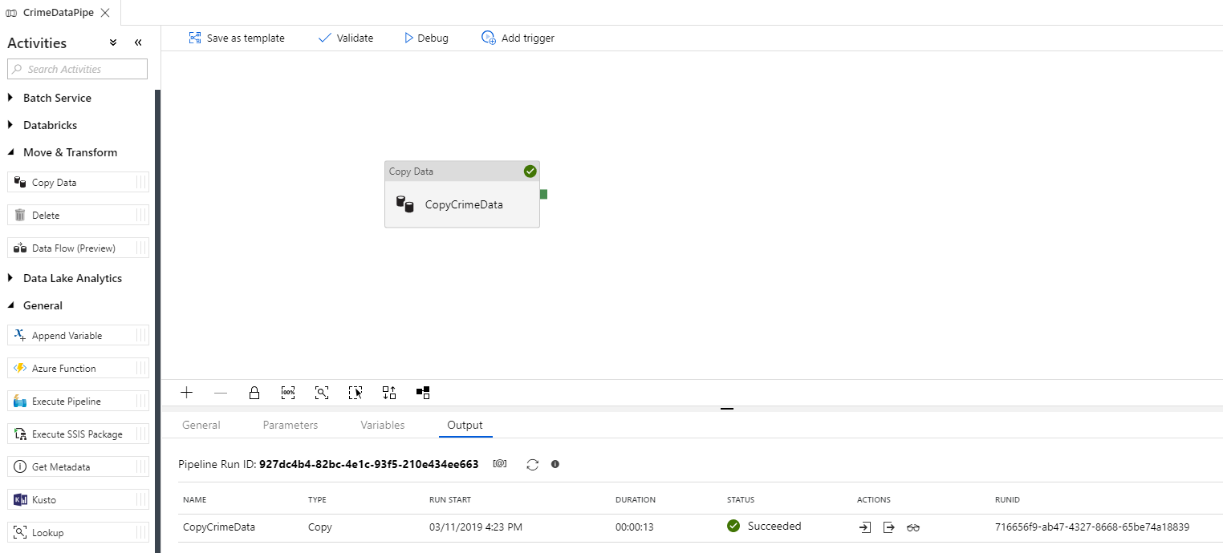

1. Verify that the file exists by using either Azure Storage explorer, or the Azure Portal to browse to the outputs container

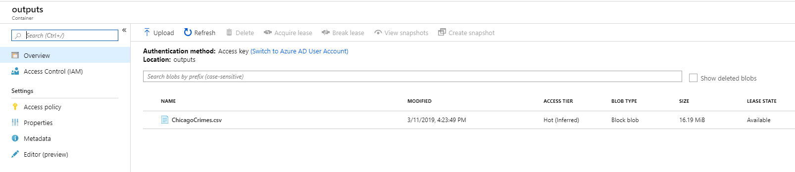

* 1. The previous steps were necessary to create the input file which will be used for the remaining steps in this exercise

1. In the ***Data Factory UI***, click the ellipse (…) to the right of Data Flows and select ***Add Data Flow.*** Name the new Data Flow ***CrimeData***

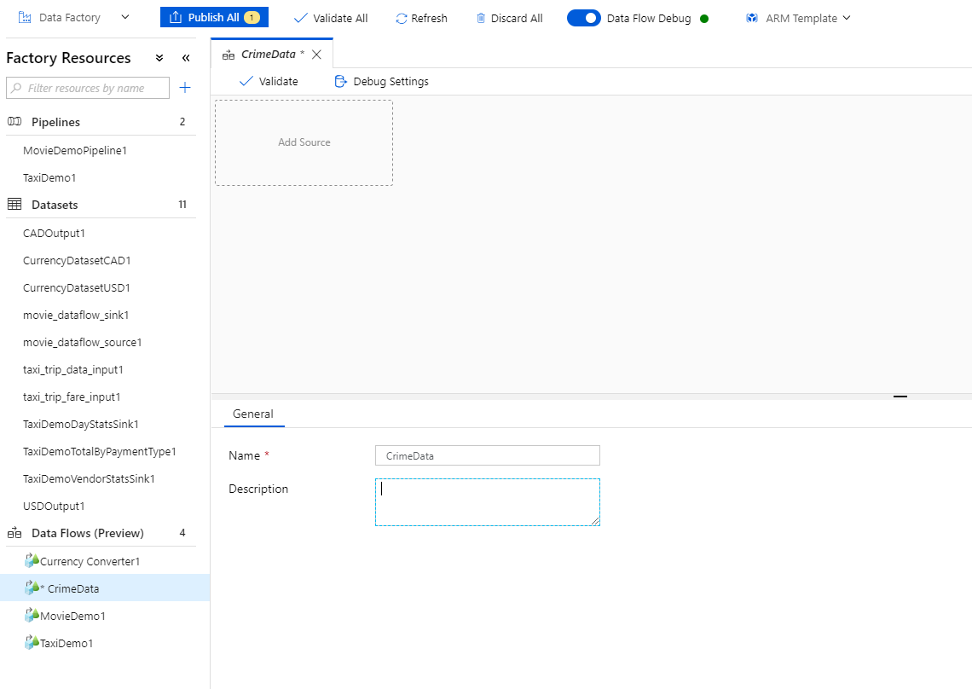

1. Click ***Add Source*** and name the Output stream ***CrimeDataFile***

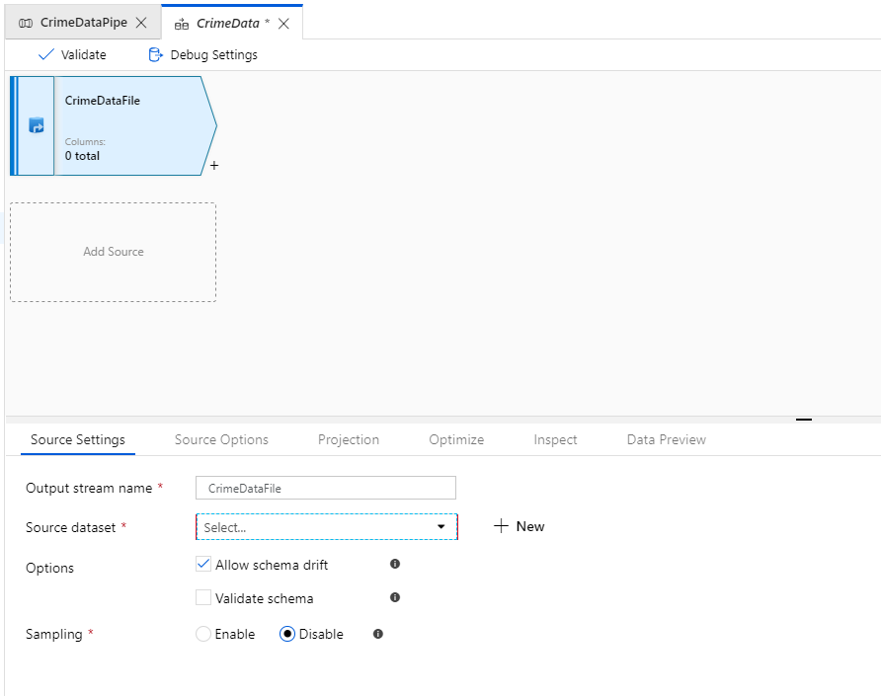

1. Click ***New*** next to ***Source dataset*** to create a new dataset connection and select ***Delimited Text***

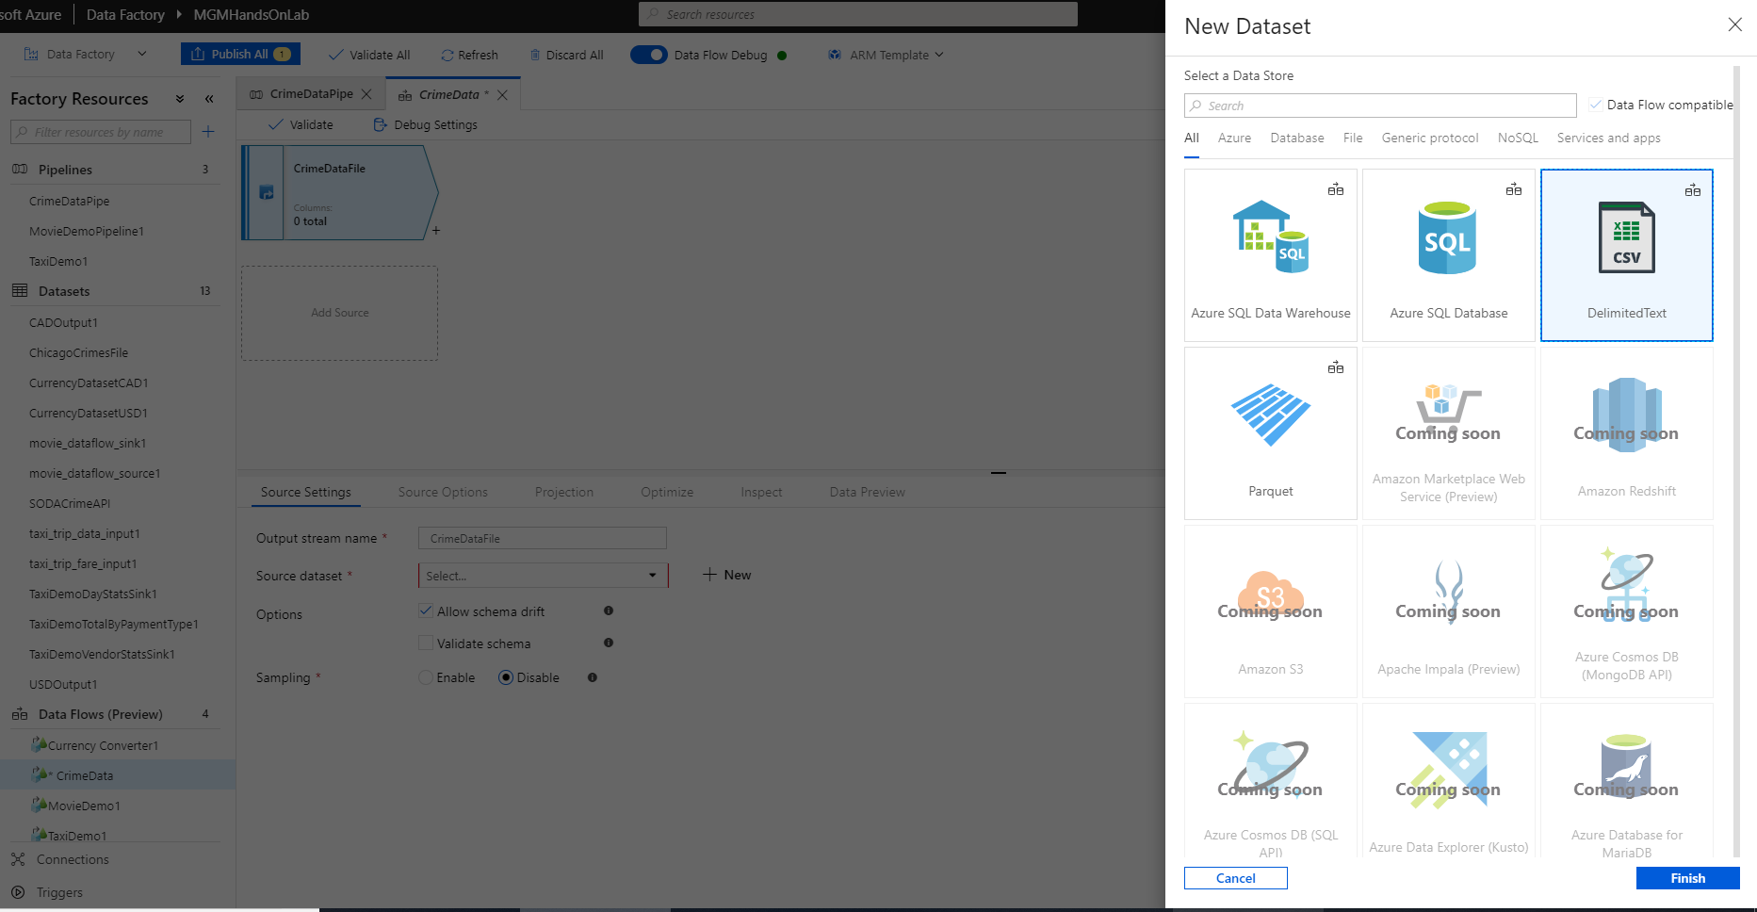

1. Select ***Finish*** and in the ***New Dataset*** dialog, enter ***ChicagoCrimeFile*** as the name, select ***LabSample*** as the Linked service, click ***Browse*** and browse to the file created above. Select ***First row as header*** to complete the Dataset configuration.

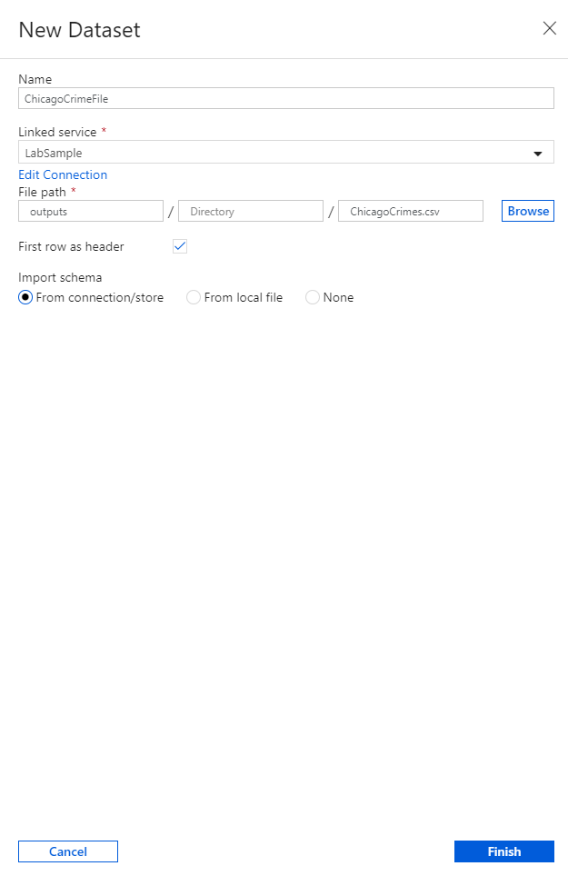

1. Click ***Finish*** to create the new dataset.

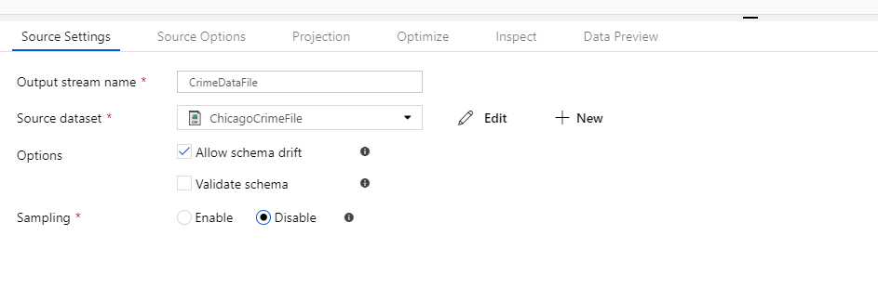

1. On the ***Data Preview*** tab, select ***Fetch latest data preview*** (wait for the cluster to start if it has timed out)

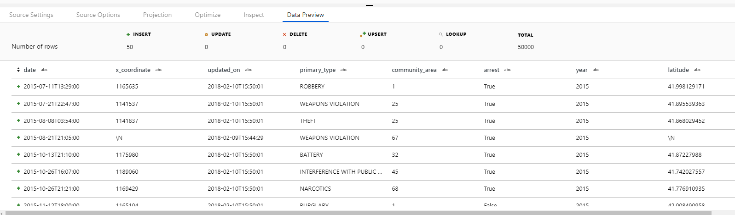

1. In the Data Flows UI, click the + next to the ***CrimeData*** object, and select ***Derived Column***

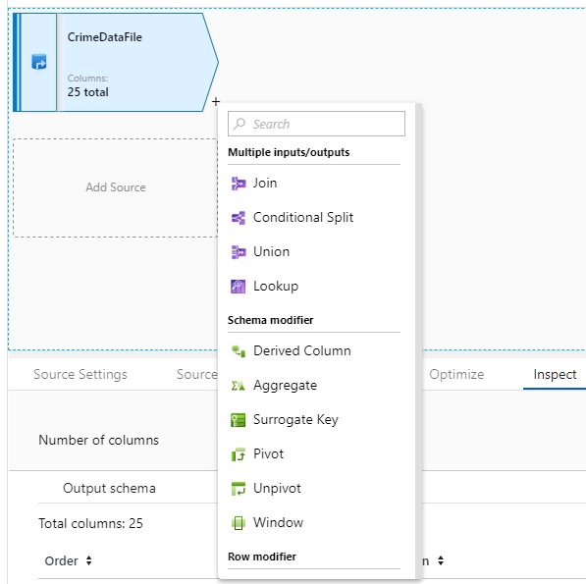

1. In the ***Derived Columns Settings***, enter ***ExtractDateTime*** for the name, and in the Columns section, name the first column ***Date***, and use the function ***left(date,10)***. Add a new column (click the + to the right of the function) and name the second column ***Time***. Use the function ***right(date,8)***

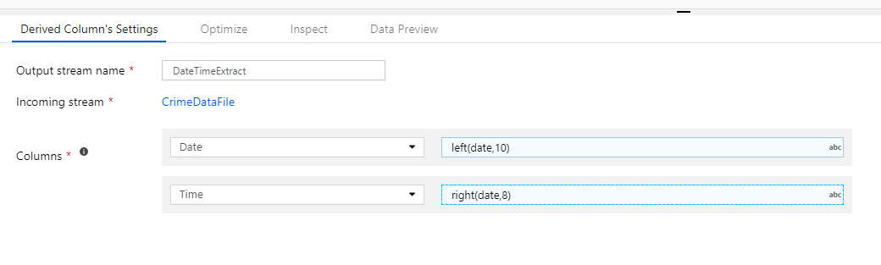

1. Click the ***Data Preview*** tab and select ***Fetch latest preview data***

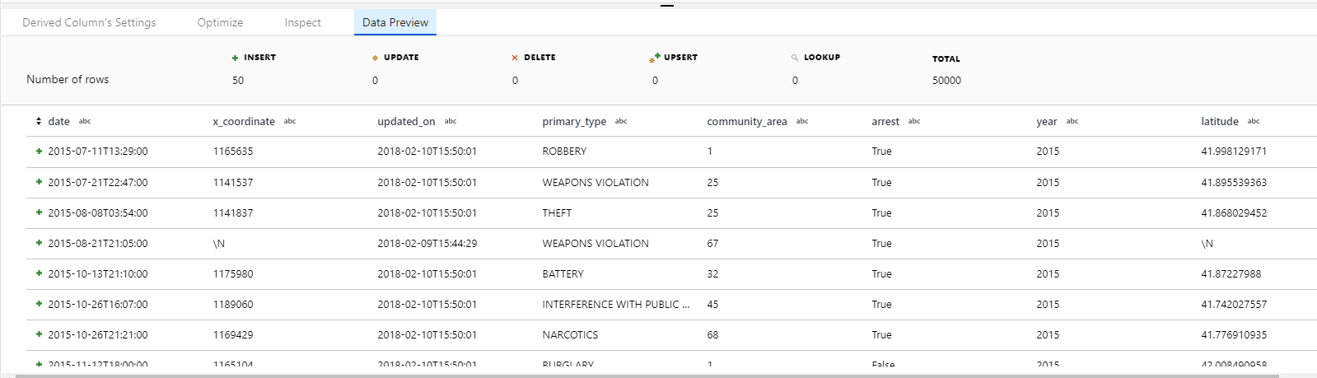

* 1. Note that you will not see the new columns as the preview only displays a sample of the columns

1. In the ***Data Flow UI***, click the + next to the ***DateTimeExtract*** object and select ***Aggregate***. Name the Aggregate ***DayOfWeekCount*** and in the column field, select Derived column. Use dayOfWeek(toDate(DateTimeExtract@Date,'yyyy-mm-dd')) as the derived column

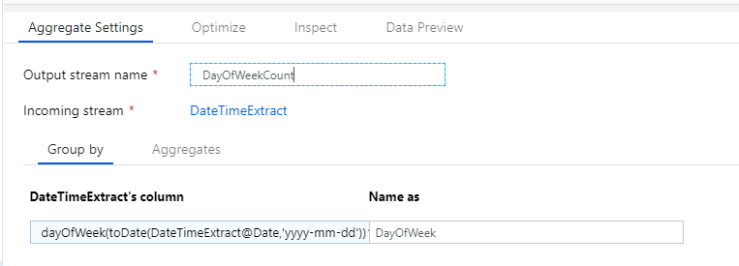

1. Name the column ***DayOfWeek*** and then select the Aggregates tab. Select the iucr column and for the aggregate function enter count(iucr)

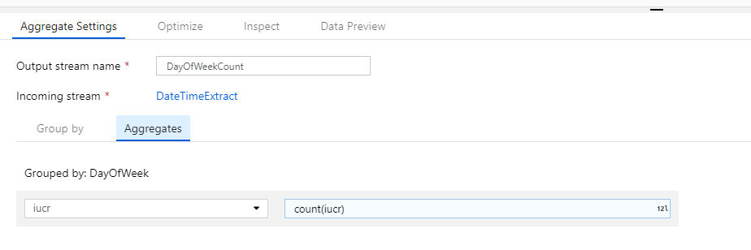

1. Click the Data Preview tab and then click Fetch latest preview data to validate the results

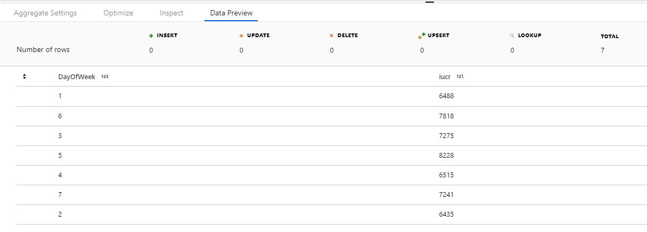

* 1. This is just a simple example of how to use a function against a derived column to calculate an aggregation.

1. In the ***Data Flows UI***, select the **+** symbol to the right of the ***DateTimeExtract*** object and select ***New Branch***

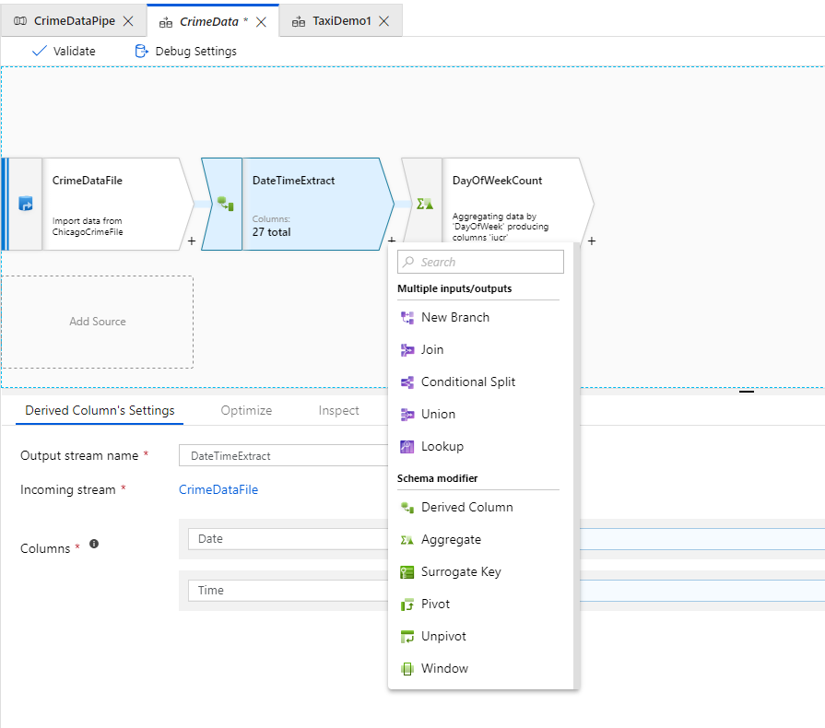

1. Select the + symbol to the right of the new DateTimeExtract object and select Filter from the menu (you will have to scroll down)

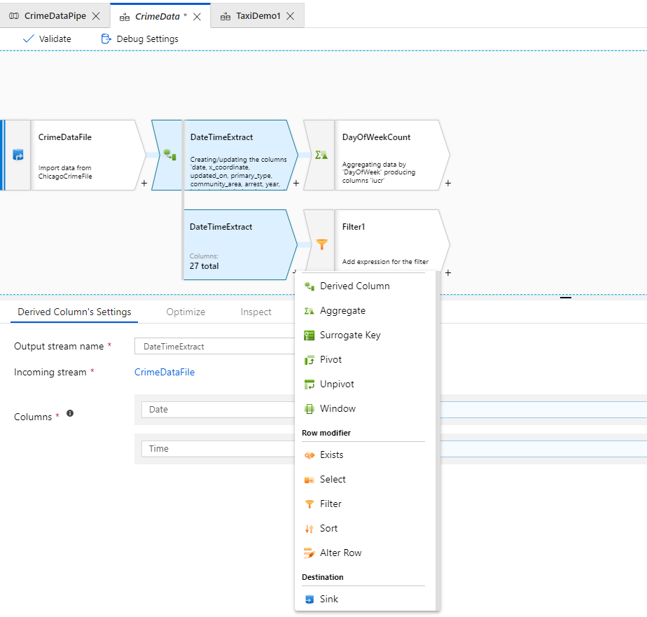

1. Name the new object Only2016 and in the Filter Settings, use year(toDate(DateTimeExtract@Date))==2016 as the filter

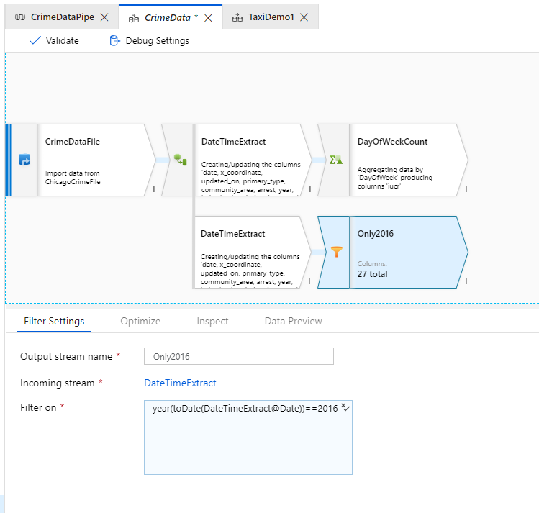

1. Select the ***Data Preview*** tab and ***Fetch latest preview data***

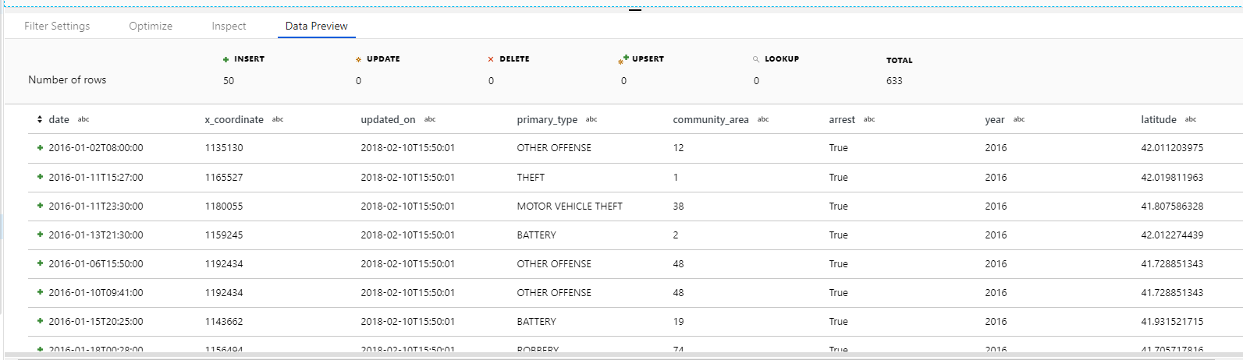

* 1. Note that the rows have been properly filtered to only include 2016 data

1. In the Data Flow UI, select the + to the right of the Only2016 object and select Sink (you will have to scroll to the bottom)

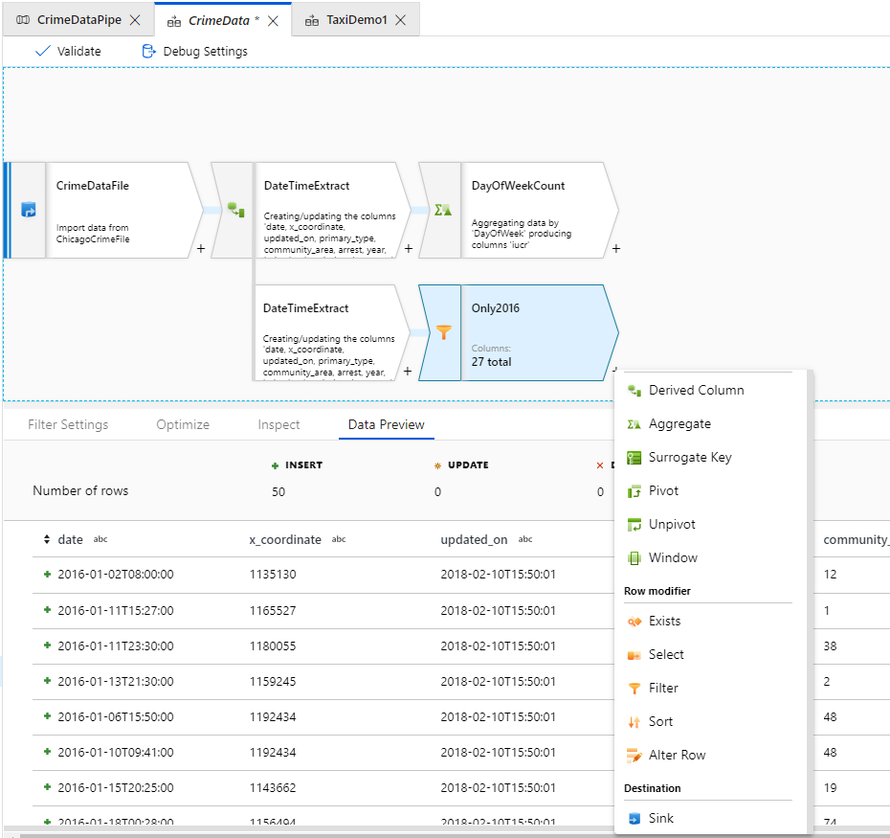

1. Name the new object ***SQLDatabase*** and select ***New*** to the right of ***Sink dataset***, then select ***Azure SQL Database***. Select ***Finish***

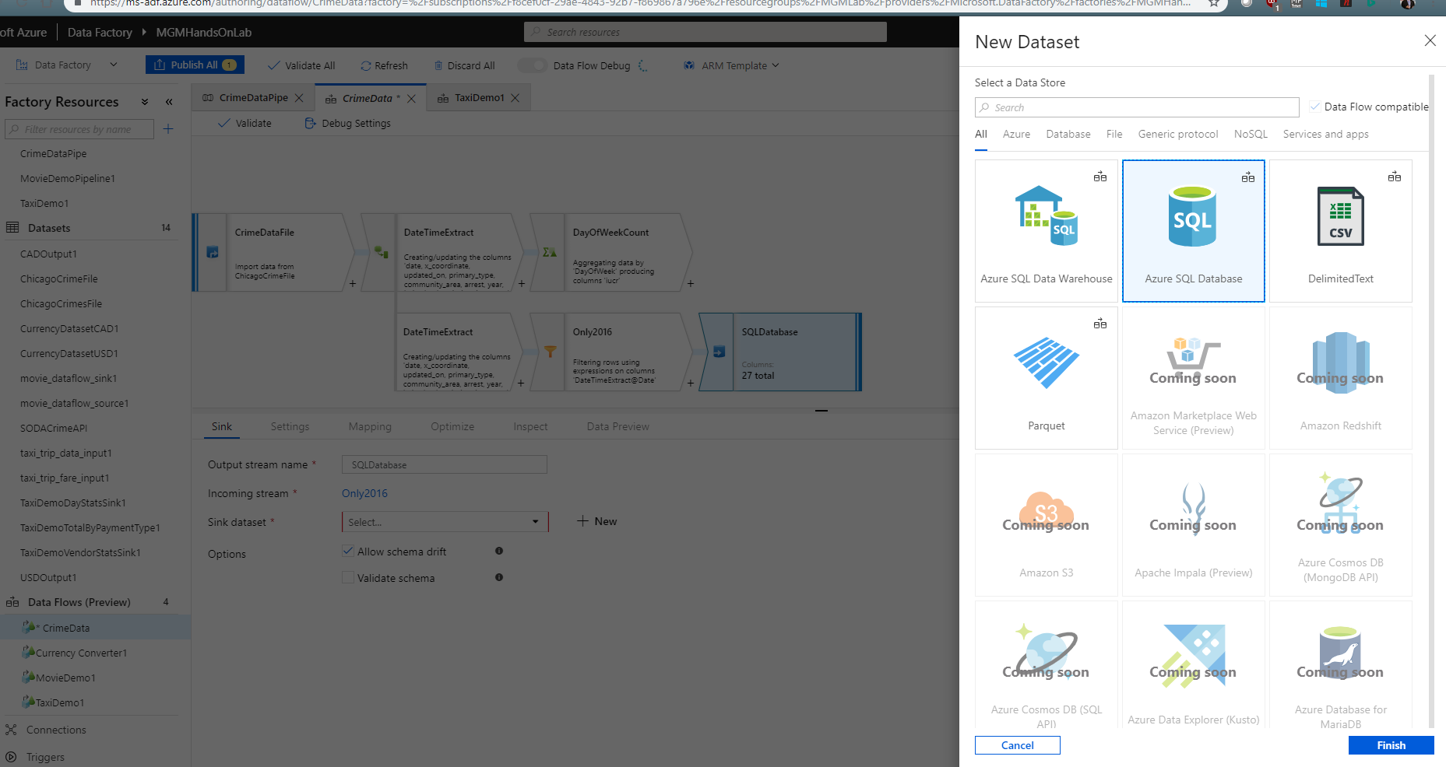

1. In the ***New Linked Service*** dialog, select ***New*** and fill out the details using the SQL Database that you created as part of the prerequisites to this lab.

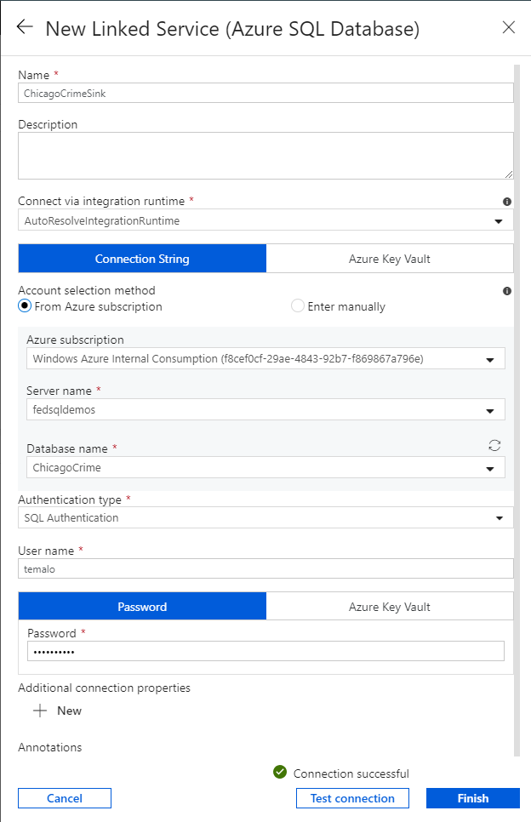

1. Click ***Test connection***, and then ***Finish*** once the connection is successful.

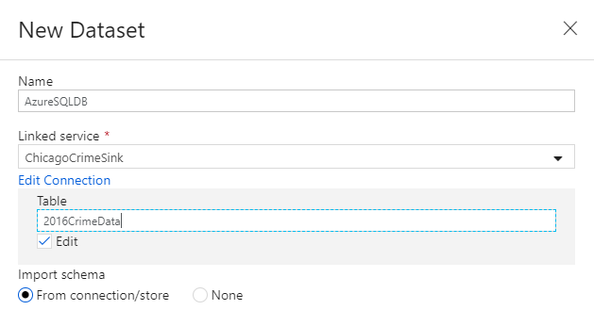

1. In the ***New Dataset*** dialog, check the ***Edit*** box, and use ***2016CrimeData*** as the table name. Select ***None*** in the ***Import schema*** radio button
2. In the SQLDatabase object, select the Mapping tab and turn off Auto Mapping. Rename the original date column to OldDate

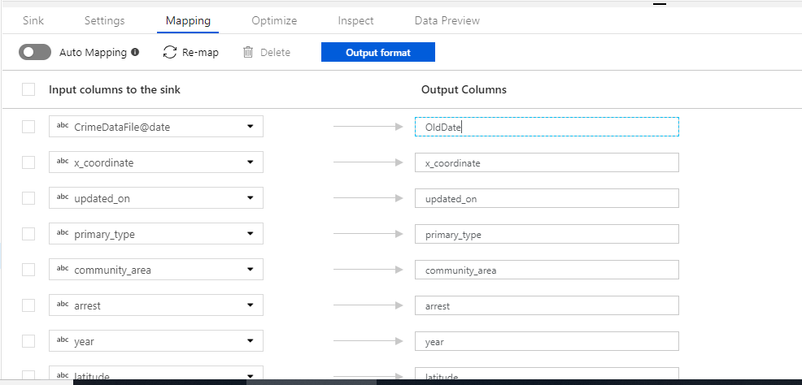

1. Select the Data Preview tab and then Fetch latest preview data

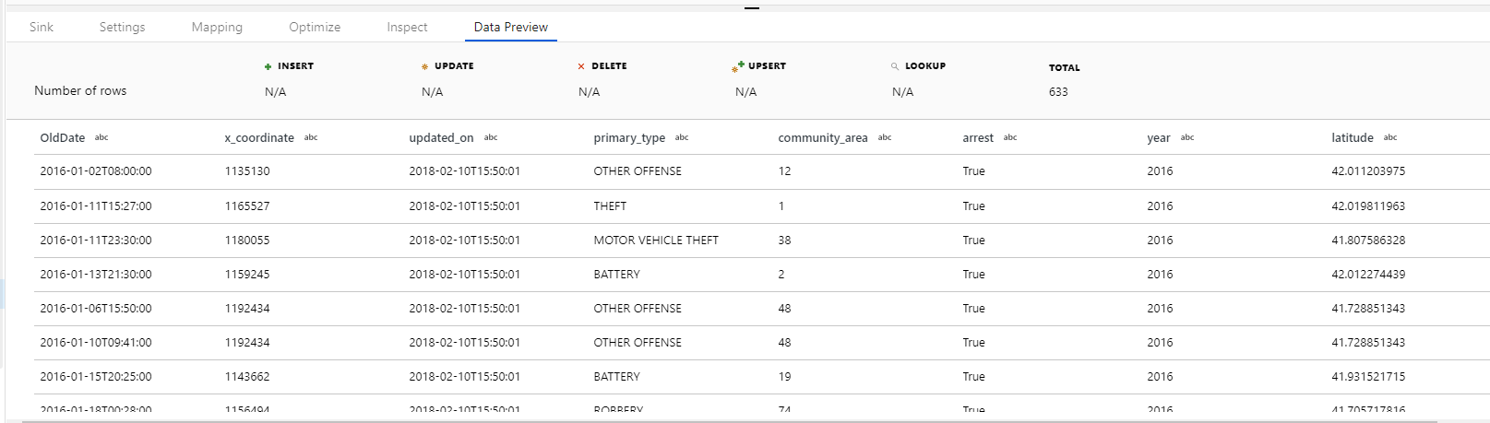

* 1. Note the renamed date column
  2. The Data Flow is now ready to execute

1. In the Data Factory UI, select the ***CrimeDataPipe*** tab, and drag a ***Data Flow*** object onto the canvas to the right of the ***CopyCrimeData*** object already present

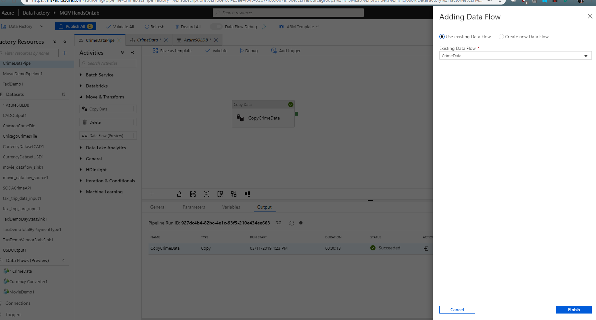

1. Select the ***CrimeData*** Data Flow in the drop down menu, and select ***Finish***

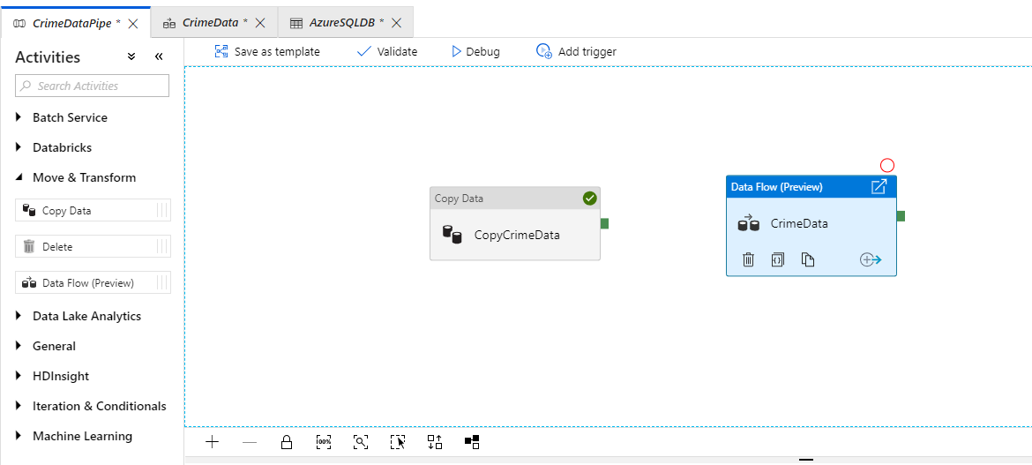

1. Using the mouse, click the green box on the right of the CopyCrimeData object and drag it to the CrimeData Data Flow object.

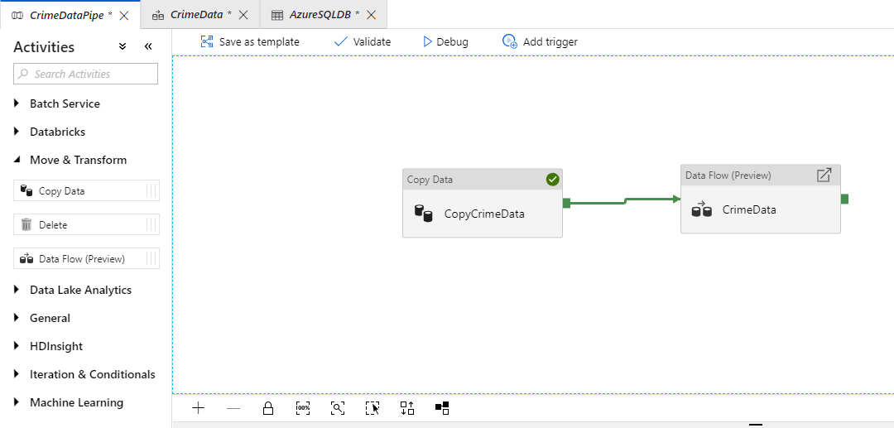

1. The pipeline is now created. The first step will contact the web service and create the CrimeData text file, and then when that successfully completes, the Data Flow you just created will execute
2. Click ***Publish All*** to save all changes
3. Click ***Debug*** to start the execution of the pipeline

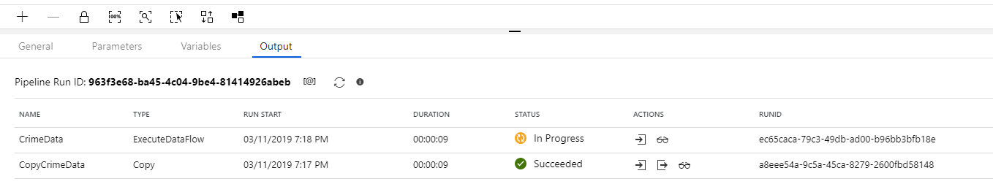

* 1. Monitor the execution of the pipeline by clicking the details (eyeglasses) icon

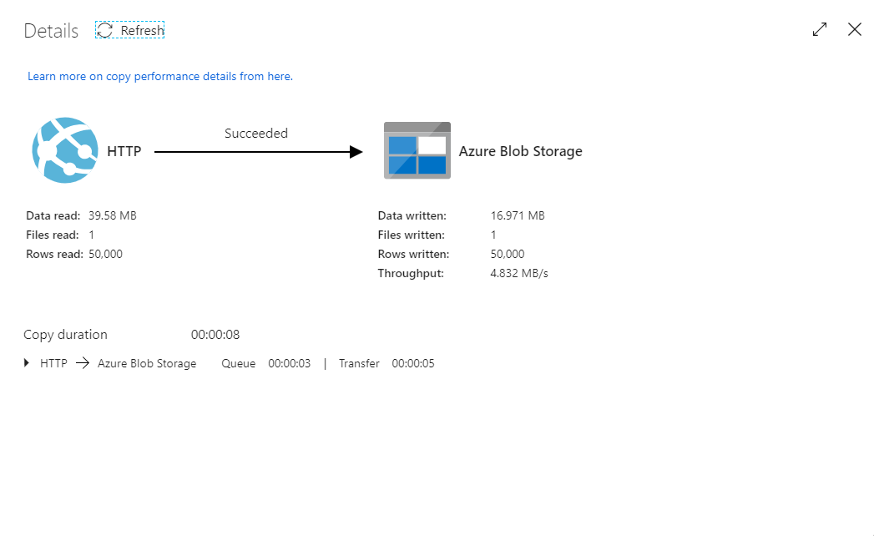

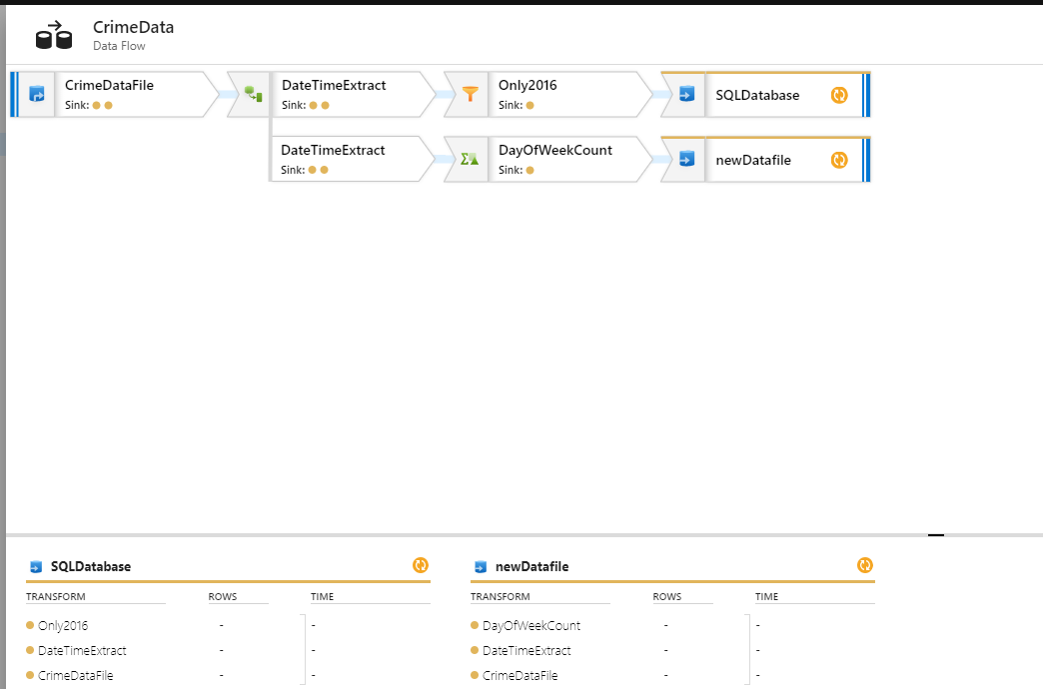

In this exercise, you used knowledge from the first two exercises to create a Data Flow that extracts data from a web service in JSON format, transform the data, and load it into a SQL Database instance.